SIMATS ENGINEERING (SAVEETHA SCHOOL OF ENGINEERING)
Department of Computer Science and Engineering
CO2 ASSESSMENT TOOL 1 – Scenario-Based Requirement Analysis

Course Code: | CSA10 / CSA1023 | Course Title: | Software Engineering
CO Assessed: | CO2 | Assessment: | Assessment Tool 2 – Scenario-Based Requirement Analysis
Weightage: | 20% | Total Marks: | 25
CO2 Statement: | Perform detailed requirements analysis, design scalable architectures, and prioritize features with a focus on cross-disciplinary skills
Student Name: | Nirmal S | Reg. No.: | 192511249
Date: | 23/10/2026 | Duration: | 60 minutes

Code of Conduct
I Nirmal S ( 192511249 ) (Name / Reg No) certify that this submission is my original work and that I have adhered to the guidelines specified for this assessment. I understand that any violation of academic integrity rules will result in disciplinary action.
Signature of the Student: S.Nirmal
Annexure A – Scenario-Based Requirement Analysis
Instructions to Students:
Each student will be assigned an individual software project problem statement. Analyze the given scenario and prepare a complete Software Requirement Analysis document by following the steps below.

Question
Based on the assigned problem statement, perform a Scenario-Based Requirement Analysis and prepare a Software Requirement Specification (SRS) document. Your analysis should include the following:
- Study and Analyze the Scenario
  - Carefully understand the given problem statement.
  - Identify the business domain, stakeholders, existing challenges, and system objectives.
- Identify Functional and Non-Functional Requirements
  - List all functional requirements required by the proposed system.
  - Identify suitable non-functional requirements such as performance, security, reliability, usability, scalability, maintainability, and availability.
- Identify Actors and Use Cases
  - Identify all primary and secondary actors interacting with the system.
  - List the major use cases associated with each actor.
  - Draw a Use Case Diagram representing the interactions between actors and the system.
- Prepare the Software Requirement Specification (SRS)
Develop an SRS document containing:
  - Introduction
  - Problem Description
  - Scope of the System
  - Functional Requirements
  - Non-Functional Requirements
  - Use Case Descriptions
  - Data Requirements
  - External Interface Requirements
  - System Features
- Identify Assumptions and Constraints
  - List the assumptions considered while developing the system.
  - Identify technical, operational, economic, legal, and time-related constraints affecting the project.
- Validate Requirement Completeness and Consistency
  - Verify whether all stakeholder requirements have been addressed.
  - Check for ambiguity, redundancy, inconsistency, and missing requirements.
  - Suggest improvements to enhance the quality and completeness of the requirement specification.
Problem Statement:
29. Privacy-Preserving Smart Retail Analytics Platform
Industry Context
Retailers use digital analytics to understand customer movement, product demand, inventory, and store operations.
Excessive collection of customer data can create privacy concerns while limiting data collection may reduce
analytical value.

Problem Statement
Design and develop a Privacy-Preserving Smart Retail Analytics Platform that provides useful operational
analytics while minimizing the collection and exposure of personally identifiable information.
The platform should integrate event-driven data processing, dashboards, secure APIs, access control, monitoring,
testing, and CI/CD. Privacy policies and data-retention controls should be built into the architecture.
Objectives

The platform should:
• Provide real-time retail operational analytics
• Minimize unnecessary collection of customer information
• Implement secure data processing and access control
• Maintain audit trails and retention policies
• Use scalable event-driven services
• Support automated testing and CI/CD
• Address ethical and privacy requirements

Expected Outcomes
The proposed platform will:
• Improve retail operational visibility
• Reduce privacy risks
• Support data-driven decision-making
• Improve scalability and reliability
• Strengthen responsible data management
Reduce manual analytics effort

1. Study and Analyze the Scenario

1.1 Understanding the Assigned Scenario
The assigned problem statement is Project 29 – Privacy-Preserving Smart Retail Analytics Platform. Retailers use digital analytics to understand how customers move through a store, which products are in demand, how much stock is available and how store operations are performing. The more detailed the customer data, the better the analytics – but excessive collection of personal data (faces, phone numbers, device identifiers, purchase histories linked to a person) creates privacy risk, legal exposure and loss of customer trust. Collecting too little data, on the other hand, reduces the business value of the analytics.
The task is therefore to specify a platform that gives retail teams useful, real-time operational analytics while collecting, storing and exposing as little personally identifiable information (PII) as possible. The platform must combine event-driven data processing, dashboards, secure APIs, access control, monitoring, automated testing and CI/CD, with privacy policies and data-retention controls built into the architecture itself ("privacy by design and by default") rather than added afterwards.
The key analytical insight of this requirement analysis is that privacy and analytics are not opposites for operational questions. Store managers need to know *how many* people entered a zone, *how long* the queue is and *which* shelf is empty – not *who* the people are. The platform is therefore designed around anonymous or pseudonymous event streams, aggregation thresholds and automatic deletion, so that every analytical need is met with the minimum necessary data.

1.2 Business Domain and Industry Context
- Domain: retail technology (retail analytics) combined with privacy engineering and data governance.
- Context: multi-store retail chains with POS systems, footfall counters, shelf sensors and loyalty programs that want data-driven operations without privacy violations.
- System type: event-driven, cloud-native, microservice-based analytics platform with web dashboards and REST APIs; pilot of 50 stores scalable to 500.
- Regulatory environment: India DPDP Act 2023, GDPR principles for international chains, ISO/IEC 27001 controls.

1.3 Existing Challenges (Problem Analysis)
The following challenges were derived from the problem statement and from typical retail-analytics practice. Each challenge is mapped to the requirement area that resolves it, which is how the problem analysis feeds the requirement specification.
Table 1: Existing challenges, impact and requirement response
# | Challenge | Impact on the business | Requirement response
1 | Over-collection of customer data (faces, MAC addresses, phone numbers, exact paths) | Privacy violations, regulatory penalties, loss of customer trust | Data-collection whitelist, edge anonymization, PII scanning (FR-04, FR-08, FR-09, FR-17)
2 | Analytics delayed by batch reports (hours or days) | Late reaction to stock-outs and queues; lost sales | Event-driven streaming with ≤ 5 s latency (FR-25, FR-27, NFR-P1)
3 | Inconsistent data across POS, sensors and inventory systems | Unreliable KPIs; mistrust of dashboards | Schema registry, validation, idempotent ingestion (FR-03, FR-05)
4 | No clear retention or deletion practice | Unbounded data growth; non-compliance with storage limitation | Configurable retention, automatic purge, legal hold (FR-49 to FR-52)
5 | Weak access control – everyone sees everything | Insider misuse, data leakage | SSO + MFA, RBAC and row-level scope (FR-38 to FR-41)
6 | No audit trail of who accessed which data | Cannot prove compliance; slow incident investigation | Tamper-evident audit trail and audit search (FR-46 to FR-48)
7 | Monolithic analytics tools that do not scale to more stores | Performance degradation and high cost when stores are added | Event-driven microservices, auto-scaling (FR-61, NFR-SC1, NFR-SC2)
8 | Manual report building and manual deployments | Effort, human error, slow releases | Scheduled reports, automated CI/CD with quality gates (FR-30, FR-63 to FR-68)
9 | Conflict between marketing wishes (individual journeys) and privacy | Stakeholder disputes, scope creep | Documented trade-off rules: same-day journeys only, aggregates for long-term insight (INC-2)
10 | Privacy handled as an afterthought | Expensive redesign; privacy by design not demonstrable | Privacy requirements embedded in architecture and release gates (FR-65, FR-68)
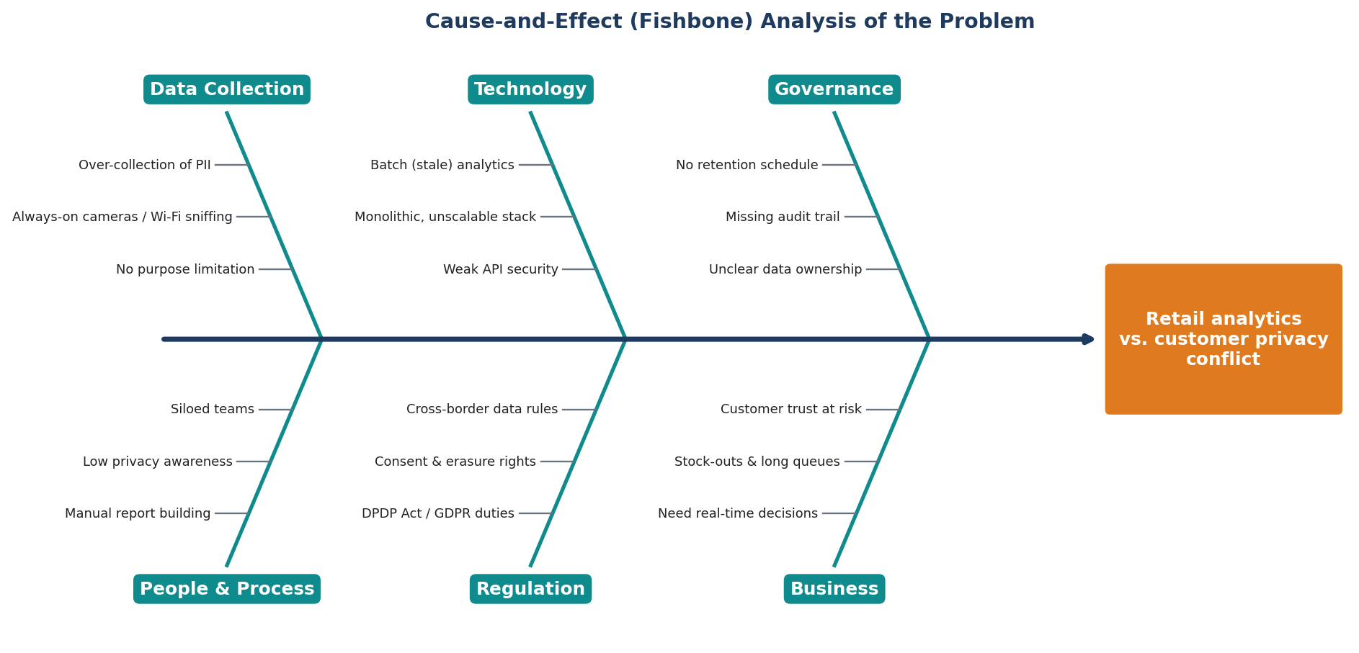
Figure 1: Cause-and-effect (fishbone) analysis of the retail analytics versus privacy problem

1.4 Stakeholder Identification and Analysis
Ten stakeholder groups were identified. They were analysed for their interest and their power over the requirements, so that conflicts can be anticipated and the right people consulted during validation.
Table 2: Stakeholder analysis
ID | Stakeholder | Role and interest in the system | Key needs / concerns | Influence
S1 | Store Manager | Runs daily store operations; uses dashboards to staff counters, manage queues and react to stock problems | Live footfall, queue and sales view; simple alerts; trustworthy numbers | High
S2 | Inventory / Supply-Chain Manager | Maintains stock availability and replenishment across stores | Real-time stock levels, stock-out alerts, demand forecast, ERP integration | Medium
S3 | Business / Marketing Analyst | Analyses trends, conversion, product performance and promotions | Flexible filters, drill-down, exports, historical comparison | Medium
S4 | Customer (Data Subject) | Visits stores and is observed by sensors; owns their personal data | Not being identified or tracked; clear notice; ability to opt out and request deletion | High (legal)
S5 | Privacy / Compliance Officer (DPO) | Ensures lawful and ethical processing; owns retention and consent rules | Data minimization proof, retention control, privacy requests, compliance reports | High
S6 | System Administrator / DevOps | Deploys, monitors and operates the platform | Observability, auto-scaling, safe releases, backups | Medium
S7 | Executive Management / Retail Owner | Sponsors the platform; accountable for risk and ROI | Chain-wide KPIs, reduced privacy risk, cost control | High
S8 | Regulators and External Auditors | Verify compliance with data-protection law and standards | Evidence: audit logs, purpose register, deletion records | High (legal)
S9 | Security Team | Protects systems and data from attack and misuse | Strong authentication, encryption, vulnerability management, incident alerts | Medium
S10 | Development and QA Team | Builds and tests the platform | Clear, testable requirements; API specifications; automated pipeline | Medium
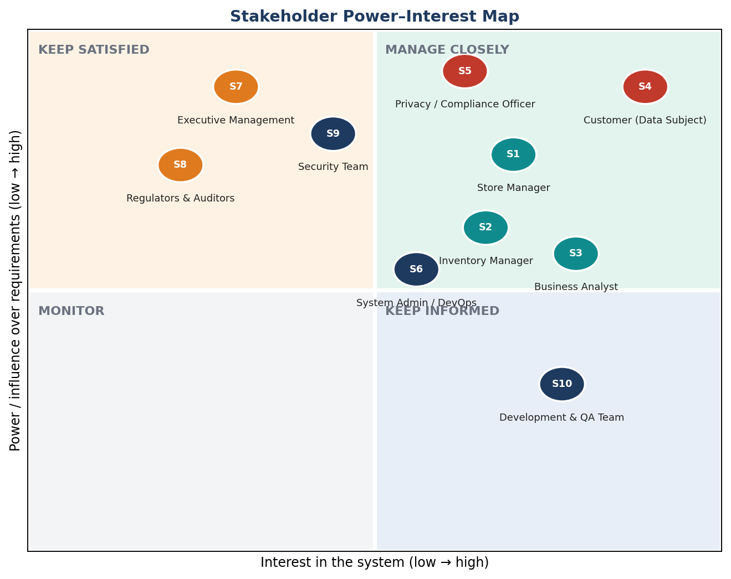
Figure 2: Stakeholder power–interest map

1.5 System Objectives and Measurable Success Criteria
The seven objectives of the problem statement were converted into measurable system objectives. This removes ambiguity and gives the project verifiable acceptance criteria.
Table 3: Objectives, measurable targets and expected outcomes
# | Objective (from problem statement) | Measurable target | Expected outcome
O1 | Provide real-time retail operational analytics | Event-to-dashboard latency ≤ 5 s (p95); KPIs refreshed every ≤ 5 s | Improved retail operational visibility
O2 | Minimize unnecessary collection of customer information | 0 PII records in analytics store; 100 % of fields from approved register; k ≥ 10 on all published cells | Reduced privacy risk
O3 | Secure data processing and access control | MFA for privileged users; RBAC on 100 % of endpoints; TLS 1.3 and AES-256; 0 critical vulnerabilities at release | Responsible, secure data management
O4 | Maintain audit trails and retention policies | 100 % of sensitive actions logged; expired data purged ≤ 24 h after expiry | Strengthened responsible data management; audit readiness
O5 | Use scalable event-driven services | 5,000 events/s per region; 50 → 500 stores; auto-scale ≤ 2 min | Improved scalability and reliability
O6 | Support automated testing and CI/CD | ≥ 80 % coverage; every commit built and tested; release gate on test, security and privacy checks | Reduced manual effort; faster, safer releases
O7 | Address ethical and privacy requirements | DPIA approved; DPDP/GDPR control mapping; ethical "Won't have" list enforced | Data-driven decisions with public trust

1.6 Design Principles Derived from the Scenario
Five privacy-by-design principles drive the requirements: data minimization (collect only whitelisted fields, counts instead of images), purpose limitation (no marketing profiling of individuals), storage limitation (30-day raw data, automatic purge), pseudonymization and aggregation (daily-rotating keyed hashes, k-anonymity with k = 10) and accountability (audit trail, DPIA, release gates).
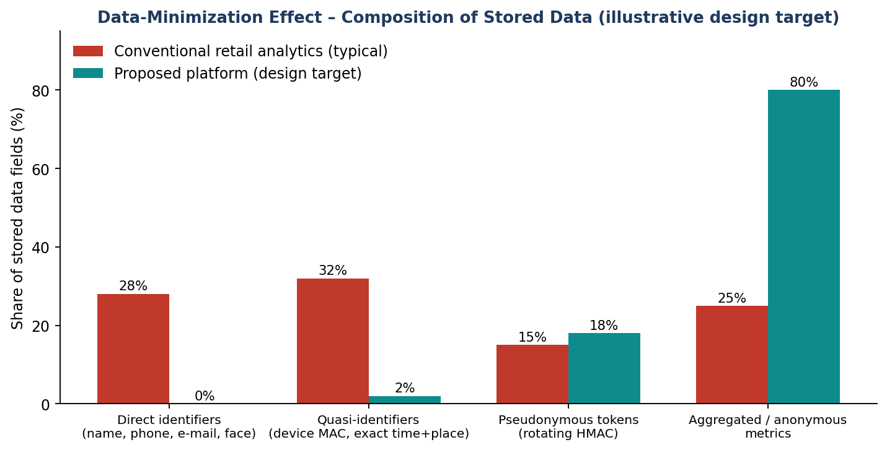
Figure 3: Effect of data minimization on the composition of stored data

1.7 System Context
The context diagram shows the system as a single process and all external entities that exchange data with it. It fixes the system boundary used throughout this document: everything inside the ellipse is built; everything outside is an actor or an external system to integrate with.
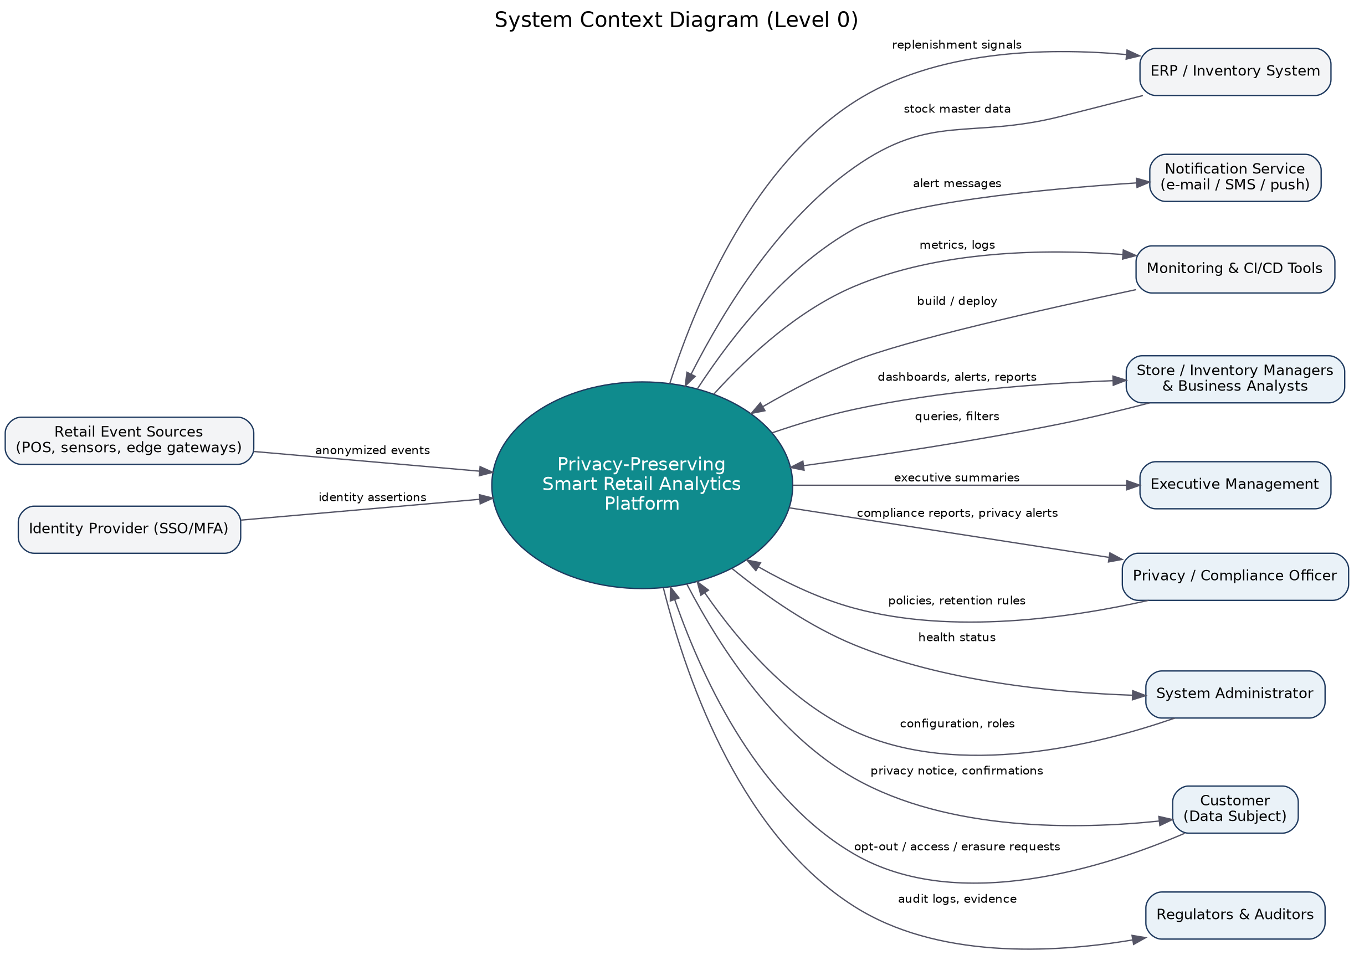
Figure 4: System context diagram (Level 0)
Summary of Step 1. The scenario belongs to the retail-analytics and privacy-engineering domain. Ten stakeholder groups, ten core challenges and seven measurable objectives were identified. The central design decision – that operational questions can be answered with anonymous, aggregated, short-lived data – drives all requirements that follow.

2. Functional and Non-Functional Requirements

2.1 Requirement Notation and Prioritization
Each requirement has a unique identifier (FR-nn for functional, NFR-xx for non-functional), a priority, the stakeholders who need it and the objective (O1–O7) it supports. Priorities follow the MoSCoW technique: Must have (release fails without it), Should have (important, can be delayed one iteration), Could have (desirable), Won't have this release. Wording uses "shall" for mandatory statements and every requirement is written to be verifiable by test, inspection or demonstration.

2.2 Functional Requirements
The platform has 68 functional requirements grouped into ten modules (A–J). Priority cells are colour-coded: red = Must, orange = Should, teal = Could.

Module A: Event Ingestion & Edge Processing
Table 4: Functional requirements – Event Ingestion & Edge Processing
ID | Requirement | Priority | Stakeholders | Objectives
FR-01 | The system shall ingest retail events (footfall counts, POS transactions, shelf/stock-sensor readings, queue length, product scans) from registered devices over MQTT or HTTPS. | Must | S1, S2 | O1, O5
FR-02 | The system shall authenticate every event source with a device certificate (mutual TLS) and reject events from unregistered or revoked devices. | Must | S9 | O3
FR-03 | The system shall validate each event against a versioned schema held in a schema registry and route invalid events to a dead-letter queue (DLQ) without processing them. | Must | S10 | O5
FR-04 | The edge gateway shall anonymize camera and sensor input locally so that only counts, zone IDs and non-identifying attributes leave the store; raw images and video shall never be stored or transmitted. | Must | S4, S5 | O2, O7
FR-05 | The system shall stamp every event with a unique event ID and ingestion timestamp, provide at-least-once delivery and apply idempotent de-duplication. | Must | S10 | O5
FR-06 | The edge gateway shall buffer events for up to 24 hours during connectivity loss and replay them in order on reconnection. | Should | S1 | O1, O5
FR-07 | Administrators shall be able to register, update and deactivate event sources and store zones from a management console. | Should | S6 | O3, O5

Module B: Privacy & Data Minimization
Table 5: Functional requirements – Privacy & Data Minimization
ID | Requirement | Priority | Stakeholders | Objectives
FR-08 | The system shall collect only the fields listed in an approved data-collection register (purpose-bound whitelist); any other field shall be dropped at ingestion. | Must | S5, S4 | O2
FR-09 | The analytics store shall not contain directly identifying data (name, phone, e-mail, face image, street address, payment-card number). | Must | S4, S5 | O2, O7
FR-10 | The system shall pseudonymize device and loyalty identifiers with keyed hashing (HMAC-SHA-256) using a key/salt rotated every 24 hours so that visitors cannot be linked across days. | Must | S4 | O2
FR-11 | The system shall apply a minimum-group threshold (k-anonymity, default k = 10) and suppress any dashboard cell representing fewer than k individuals. | Must | S4, S5 | O2, O7
FR-12 | The system shall support optional differential-privacy noise on published aggregate metrics with a configurable privacy budget (epsilon). | Could | S5 | O2, O7
FR-13 | The system shall maintain a purpose register linking every data element to a business purpose, legal basis, data owner and retention period. | Must | S5, S8 | O7, O4
FR-14 | The system shall record per-store privacy-notice status and, for any optional loyalty-linked analytics, the consent state of each pseudonymous profile. | Should | S4, S5 | O7
FR-15 | The system shall let customers opt out or withdraw consent and shall apply the choice to all pseudonymous profiles within 24 hours. | Must | S4 | O7
FR-16 | The system shall provide data-subject workflows (access, correction, erasure for loyalty-linked data) completed within 30 days. | Must | S4, S8 | O7
FR-17 | The system shall scan every ingested payload for unexpected PII patterns (phone numbers, e-mails, card numbers) and quarantine offending records. | Should | S5, S9 | O2, O3

Module C: Real-Time Analytics Engine
Table 6: Functional requirements – Real-Time Analytics Engine
ID | Requirement | Priority | Stakeholders | Objectives
FR-18 | The system shall compute footfall counts per store and zone for 1-minute, 15-minute, hourly and daily windows. | Must | S1, S3 | O1
FR-19 | The system shall compute dwell time and zone heat-maps from anonymous, same-day tracks. | Should | S3 | O1
FR-20 | The system shall estimate checkout queue length and expected waiting time. | Should | S1 | O1
FR-21 | The system shall compute sales analytics from POS events: revenue, basket size, conversion rate (footfall to transactions) and top products. | Must | S1, S3, S7 | O1
FR-22 | The system shall compute stock levels, shelf availability and detect low-stock and stock-out conditions. | Must | S2 | O1
FR-23 | The system shall forecast demand per product category and store from aggregated history (daily/weekly). | Could | S2, S3 | O1
FR-24 | The system shall detect anomalies such as abrupt footfall drops, sensor failure and abnormal returns. | Could | S1, S6 | O1, O5
FR-25 | The stream processor shall support tumbling and sliding windows and handle late events with watermarks of up to 5 minutes. | Must | S10 | O5, O1
FR-26 | The system shall store hot (real-time) and warm (historical) aggregates to support trend analysis and cross-store comparison. | Must | S3, S7 | O1, O4

Module D: Dashboard & Reporting
Table 7: Functional requirements – Dashboard & Reporting
ID | Requirement | Priority | Stakeholders | Objectives
FR-27 | The system shall provide a role-based real-time dashboard (footfall, conversion, sales, queue, stock) that refreshes at least every 5 seconds. | Must | S1, S2, S3 | O1
FR-28 | The dashboard shall offer filters (store, zone, category, time range) and drill-down from chain to store to zone. | Must | S3 | O1
FR-29 | The dashboard shall visualize heat-maps, trend lines, funnels and comparative charts. | Should | S3, S7 | O1
FR-30 | The system shall generate scheduled and on-demand reports (PDF, CSV, XLSX) that contain only k-compliant aggregate data. | Must | S1, S3, S7 | O1, O2
FR-31 | The system shall provide an executive multi-store summary view. | Should | S7 | O1
FR-32 | The system shall provide a privacy-transparency panel showing what is collected, anonymization status and retention periods. | Should | S5, S4 | O7
FR-33 | The user interface shall be responsive for desktop, tablet and mobile browsers. | Should | S1 | O1

Module E: Alerts & Notifications
Table 8: Functional requirements – Alerts & Notifications
ID | Requirement | Priority | Stakeholders | Objectives
FR-34 | The system shall support configurable threshold alerts (stock-out, queue length, footfall surge, sensor offline). | Must | S1, S2 | O1
FR-35 | The system shall deliver alerts through dashboard, e-mail and SMS/push with acknowledgement and escalation. | Should | S1, S2 | O1
FR-36 | The system shall raise privacy/security alerts (PII detected, retention failure, repeated unauthorized access) to the Compliance Officer and Security Team. | Must | S5, S9 | O3, O7
FR-37 | The system shall de-duplicate and rate-limit alerts to prevent alert fatigue. | Could | S1 | O1

Module F: Identity & Access Control
Table 9: Functional requirements – Identity & Access Control
ID | Requirement | Priority | Stakeholders | Objectives
FR-38 | The system shall authenticate users through SSO (OpenID Connect/OAuth 2.0) and enforce MFA for privileged roles. | Must | S9 | O3
FR-39 | The system shall enforce role-based access control with least privilege for the roles Store Manager, Inventory Manager, Analyst, Compliance Officer, Administrator, Auditor and Executive. | Must | S5, S9 | O3
FR-40 | The system shall restrict data scope by store/region using row-level (attribute-based) rules. | Must | S9, S1 | O3
FR-41 | The system shall provide approval-based, time-bound elevation ("break-glass") for sensitive administrative actions. | Should | S9 | O3
FR-42 | The system shall end sessions after 15 minutes of inactivity and limit concurrent sessions. | Should | S9 | O3
FR-43 | The system shall secure APIs with OAuth 2.0 scoped JWT tokens or API keys and apply rate limiting. | Must | S9, S6 | O3
FR-44 | The system shall encrypt data in transit (TLS 1.3) and at rest (AES-256) with keys held in a KMS/vault and rotated periodically. | Must | S9, S5 | O3
FR-45 | The system shall produce periodic access-review reports (who holds which role and scope). | Could | S5, S8 | O3, O4

Module G: Audit & Retention
Table 10: Functional requirements – Audit & Retention
ID | Requirement | Priority | Stakeholders | Objectives
FR-46 | The system shall keep an audit trail of log-ins, data access, exports, configuration changes, privacy requests and retention actions (who, what, when, where, outcome). | Must | S5, S8 | O4
FR-47 | Audit records shall be tamper-evident (hash-chained and stored on write-once media). | Should | S8 | O4
FR-48 | The system shall provide search, filter and export of audit logs for authorized auditors. | Must | S8 | O4
FR-49 | The system shall let the Compliance Officer configure retention periods per data class without redeployment. | Must | S5 | O4, O7
FR-50 | The system shall automatically purge or irreversibly anonymize expired data and write a deletion record for each run. | Must | S5, S8 | O4, O7
FR-51 | The system shall support legal hold that suspends deletion of specified data on authorized request. | Could | S5 | O4
FR-52 | Backups shall follow the retention policy so deleted data cannot be restored beyond a 35-day backup window. | Should | S5 | O4
FR-53 | The system shall generate a privacy-compliance report (retention adherence, consent statistics, request SLAs, k-suppression counts). | Should | S5, S8, S7 | O4, O7

Module H: API & Integration
Table 11: Functional requirements – API & Integration
ID | Requirement | Priority | Stakeholders | Objectives
FR-54 | The system shall expose an API-first, versioned (/v1) REST interface documented with OpenAPI 3.x. | Must | S10, S3 | O5
FR-55 | The system shall integrate with ERP/inventory and POS systems through adapters and webhooks. | Should | S2 | O1, O5
FR-56 | No API endpoint shall return individual-level records; all analytics endpoints shall return aggregated, privacy-safe data only. | Must | S4, S5 | O2, O3
FR-57 | The system shall provide an API sandbox with interactive documentation (Swagger UI). | Could | S10 | O5, O6

Module I: Monitoring & Operations
Table 12: Functional requirements – Monitoring & Operations
ID | Requirement | Priority | Stakeholders | Objectives
FR-58 | All services shall expose health endpoints and Prometheus metrics; Grafana dashboards shall show latency, throughput and error rates. | Must | S6 | O5
FR-59 | The system shall centralize structured logs (ELK) and redact any PII from log entries. | Must | S6, S5 | O3, O7
FR-60 | The system shall alert on pipeline lag, consumer lag, DLQ growth and sensor outage. | Must | S6 | O5, O1
FR-61 | Stateless services and stream processors shall auto-scale with load (Kubernetes HPA). | Should | S6 | O5
FR-62 | The system shall support backup and restore of configuration and aggregates within defined RPO/RTO. | Should | S6 | O5

Module J: Testing & CI/CD
Table 13: Functional requirements – Testing & CI/CD
ID | Requirement | Priority | Stakeholders | Objectives
FR-63 | The CI pipeline shall build, lint and unit-test every commit (GitHub Actions / Jenkins). | Must | S10 | O6
FR-64 | The test suite shall include unit, integration, API-contract, end-to-end and load tests with at least 80 % coverage on core modules. | Must | S10 | O6
FR-65 | Automated privacy tests shall verify no PII leakage, k-threshold enforcement, retention purge and access-control rules on every release. | Must | S5, S9 | O6, O7
FR-66 | The pipeline shall run SAST, DAST, dependency and container-image scans and fail the build on critical findings. | Must | S9 | O6, O3
FR-67 | Deployments shall be containerized (Docker/Kubernetes, Terraform IaC) using blue-green or rolling updates with automatic rollback. | Should | S6 | O6, O5
FR-68 | A release gate shall block deployment unless all test, security and privacy checks pass. | Must | S5, S10 | O6, O7

2.3 Explicitly Excluded Functions (Won't Have)
Ethical scoping is itself a requirement. The following functions are deliberately excluded because they contradict the privacy objectives. Excluding them in writing prevents scope creep and gives the privacy officer a basis to reject such requests.
- WN-01 Facial recognition or biometric identification of shoppers – Violates data-minimization and ethics objectives.
- WN-02 Cross-day or cross-store tracking of individual visitors – Contradicts 24-hour key rotation (FR-10).
- WN-03 Selling or sharing individual-level data with third parties – No legal basis; conflicts with purpose limitation.
- WN-04 Emotion/demographic inference from facial images – Sensitive inference; high ethical risk.
- WN-05 Personalised advertising or price discrimination per individual – Outside the operational-analytics purpose.
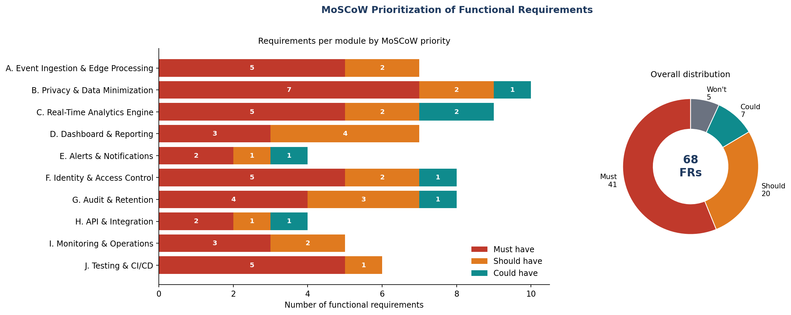
Figure 5: MoSCoW prioritization of functional requirements by module

2.4 Non-Functional Requirements
Thirty-eight measurable non-functional requirements were identified across twelve quality categories: performance, security, privacy, reliability, availability, scalability, usability, maintainability, compliance, interoperability, observability and sustainability. Each has a target metric so it can be tested.
Table 14: Non-functional requirements with measurable targets
ID | Requirement | Target metric
Performance
NFR-P1 | End-to-end latency from event capture to dashboard shall be ≤ 5 s (95th percentile) at nominal load. | 5 s p95
NFR-P2 | Dashboard first load ≤ 3 s; chart refresh ≤ 2 s on a 10 Mbps link. | 3 s / 2 s
NFR-P3 | Aggregate API queries ≤ 300 ms p95 for ≤ 7 days of data and ≤ 2 s for 13 months. | 300 ms / 2 s
NFR-P4 | Sustain 5,000 events/s per region at peak with 3× headroom. | 5,000 ev/s
NFR-P5 | Pseudonymization and PII-scan overhead ≤ 50 ms per event on average. | ≤ 50 ms
Security
NFR-S1 | All traffic TLS 1.3; stored data AES-256; keys rotated at least every 90 days. | TLS 1.3 / AES-256
NFR-S2 | Mitigate OWASP Top-10; zero open critical/high vulnerabilities at release. | 0 critical/high
NFR-S3 | MFA for privileged users; account lock after 5 failed log-ins. | MFA, 5 attempts
NFR-S4 | Secrets are stored in a vault; none in source code or images. | 0 secrets in repo
NFR-S5 | Independent penetration test before go-live and annually. | 1 / year
Privacy
NFR-PR1 | Zero PII in the analytics store, verified by automated scans on a seeded test corpus. | 0 PII records
NFR-PR2 | k-anonymity (k ≥ 10) enforced for 100 % of published aggregates. | 100 %
NFR-PR3 | A Data-Protection Impact Assessment (DPIA) is completed and approved before release. | 1 DPIA
NFR-PR4 | Expired data purged within 24 hours of expiry; success rate 100 %. | ≤ 24 h
NFR-PR5 | Data-subject requests answered within 30 days (target ≤ 7 days). | ≤ 30 d
Reliability
NFR-R1 | ≥ 99.99 % of events processed with exactly-once effect (no loss, no duplicates). | 99.99 %
NFR-R2 | Mean time to recovery for Severity-1 incidents ≤ 30 minutes. | MTTR ≤ 30 min
NFR-R3 | Graceful degradation: dashboard shows last-known cached data with a staleness banner if streaming is down. | Cached view
NFR-R4 | Recovery Point Objective ≤ 15 min; Recovery Time Objective ≤ 1 hour. | RPO 15 m / RTO 1 h
Availability
NFR-A1 | Dashboards and APIs available 99.9 % per month (≈ 43.8 min allowed downtime). | 99.9 %
NFR-A2 | Event ingestion available 99.95 % per month. | 99.95 %
NFR-A3 | Deployments cause zero user-visible downtime. | 0 downtime
Scalability
NFR-SC1 | Scale horizontally from 50 to 500 stores without architectural change. | 10× stores
NFR-SC2 | Auto-scale stream processors and APIs within 2 minutes of a load spike. | ≤ 2 min
NFR-SC3 | Support multi-tenant retail chains with logical data isolation. | Tenant isolation
Usability
NFR-U1 | New users complete core tasks after ≤ 30 min training; SUS score ≥ 75. | SUS ≥ 75
NFR-U2 | Conform to WCAG 2.1 level AA. | WCAG 2.1 AA
NFR-U3 | Internationalization-ready (English, Tamil, Hindi) with local date/currency formats. | 3 languages
NFR-U4 | Privacy information presented in plain language (readability grade ≤ 8). | Grade ≤ 8
Maintainability
NFR-M1 | Loosely coupled microservices; each service owns one bounded context and its data. | 1 context / service
NFR-M2 | Static-analysis quality gate (maintainability rating A) and ≥ 80 % test coverage. | Rating A, 80 %
NFR-M3 | OpenAPI specs, architecture decision records and runbooks kept current. | Docs per release
NFR-M4 | Policies (retention, k, alert thresholds) are configuration-driven, changeable without redeployment. | No redeploy
Compliance
NFR-C1 | Align with India DPDP Act 2023 and GDPR principles; controls mapped to ISO/IEC 27001. | Control map
NFR-C2 | Audit logs retained ≥ 12 months online and tamper-evident. | ≥ 12 months
Interoperability
NFR-I1 | Use open standards (OpenAPI, OIDC, MQTT, CloudEvents); deployable on any Kubernetes cluster. | No lock-in
Observability
NFR-O1 | 100 % of services emit metrics, structured logs and traces with correlation IDs. | 100 %
Sustainability
NFR-G1 | Target 60–70 % average CPU utilization and efficient CI pipelines to limit energy use. | 60–70 % CPU
Summary of Step 2. The specification contains 68 functional requirements (41 Must, 20 Should, 7 Could), 5 explicit exclusions and 38 measurable non-functional requirements, classified by module and quality category and prioritised with MoSCoW.

3. Actors and Use Cases

3.1 Primary Actors
Primary actors initiate interactions to achieve a goal.
Table 15: Primary actors
Actor | Description | Main goals
Store Manager | Manages one or more stores; sees store-scope data | Monitor live footfall, queues, sales; receive alerts; export store reports
Inventory Manager | Controls stock and replenishment for assigned stores/regions | Monitor stock, receive stock-out alerts, use demand forecast
Business Analyst | Analyses trends across stores; sees aggregate data only | Filter, compare and export aggregate analytics; study heat-maps
Privacy / Compliance Officer (DPO) | Owns privacy policy and compliance evidence | Configure retention, process customer requests, review audit logs and compliance reports
System Administrator | Operates and configures the platform | Manage roles, API keys, integrations, health, deployments
Customer (Data Subject) | Person visiting the store; indirect actor | Exercise opt-out, access and erasure rights
Executive | Senior management; read-only | View multi-store KPIs and compliance summary

3.2 Secondary Actors
Secondary actors support the system or receive services from it but do not start the primary goal.
Table 16: Secondary actors
Actor | Type | Interaction
Retail Event Sources (POS, sensors, edge gateways) | External devices | Push anonymized events using MQTT/HTTPS with device certificates
Identity Provider (SSO/MFA) | External system | Authenticates users; supplies identity and group claims (OIDC)
Notification Service (e-mail/SMS/push) | External service | Delivers alerts and report links
ERP / Inventory System | External system | Supplies stock master data; receives replenishment signals
External Auditor / Regulator | Human, read-only | Reviews audit logs and compliance reports (through the DPO or the Auditor role)
Monitoring and CI/CD Tools | External tooling | Collect metrics/logs; build, test and deploy releases
Scheduler (Time) | Internal timer actor | Triggers retention purge, scheduled reports and key rotation

3.3 Use Case List
Table 17: Major use cases with actors and related requirements
ID | Use case | Actor(s) | Related requirements
UC01 | Authenticate and Authorize | All users; Identity Provider | FR-38 – FR-42
UC02 | View Real-Time Dashboard | Store Mgr, Inventory Mgr, Analyst, Executive | FR-18 – FR-22, FR-27 – FR-29
UC03 | Analyze Footfall and Zone Heat-maps | Store Mgr, Analyst | FR-18, FR-19, FR-28, FR-29
UC04 | Monitor Inventory and Stock Levels | Inventory Mgr, Store Mgr; ERP | FR-22, FR-34, FR-55
UC05 | Receive Operational Alerts | Store Mgr, Inventory Mgr; Notification Service | FR-34, FR-35, FR-37
UC06 | Generate and Export Reports | Store Mgr, Analyst, Executive | FR-30, FR-31
UC07 | Ingest Retail Events | Retail Event Sources | FR-01 – FR-07
UC08 | Anonymize and Pseudonymize Data | System (included by UC07) | FR-04, FR-08 – FR-11, FR-17
UC09 | Manage Role-Based Access | System Administrator | FR-39 – FR-41, FR-45
UC10 | Configure Retention Policies | Privacy Officer | FR-49, FR-51
UC11 | Review Audit Logs | Privacy Officer, Auditor, Administrator | FR-46 – FR-48
UC12 | Handle Privacy Requests | Customer, Privacy Officer | FR-14 – FR-16
UC13 | Monitor System Health | System Administrator; Monitoring Tools | FR-58 – FR-62
UC14 | Manage API Keys and Integrations | System Administrator; ERP | FR-43, FR-54 – FR-57
UC15 | Run Privacy Compliance Report | Privacy Officer, Auditor | FR-45, FR-53
UC16 | Forecast Demand | Inventory Mgr, Analyst | FR-23
UC17 | Purge Expired Data | Scheduler; Privacy Officer (oversight) | FR-50, FR-52
UC18 | Deploy via CI/CD Pipeline | System Administrator; CI/CD Tools | FR-63 – FR-68

3.4 Use Case Diagram
The UML use case diagram below follows UML 2.x conventions: a system boundary rectangle, stick figures for human actors, «system» rectangles for external-system actors, ellipses for use cases, solid lines for associations and dashed arrows for «include» and «extend» relationships.
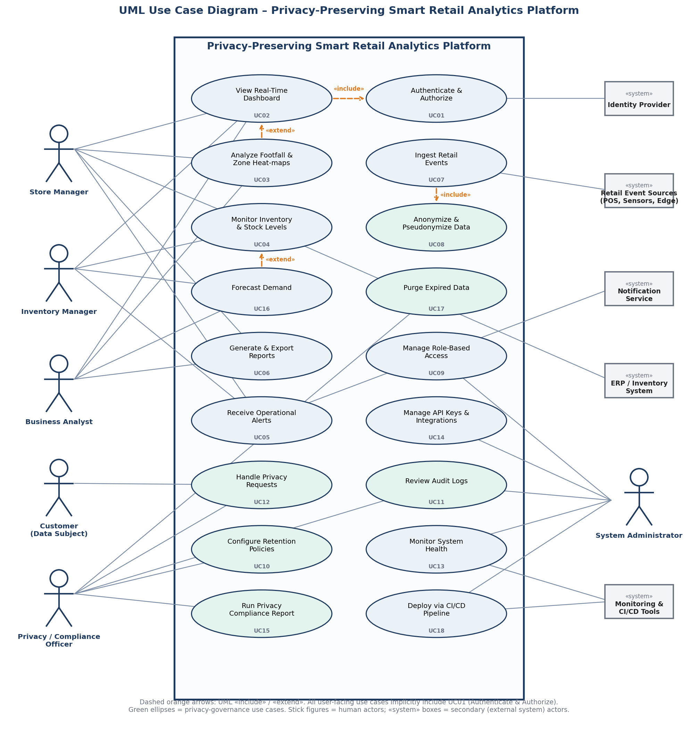
Figure 6: UML use case diagram of the Privacy-Preserving Smart Retail Analytics Platform

Relationships in the diagram
- «include» – UC07 (Ingest Retail Events) always includes UC08 (Anonymize and Pseudonymize Data), so no event reaches storage un-anonymized. UC02 includes UC01 (Authenticate and Authorize); every user-facing use case implicitly does the same.
- «extend» – UC03 (heat-map analysis) optionally extends UC02 (dashboard) when the user drills down; UC16 (forecast) optionally extends UC04 (inventory monitoring) when historical data is sufficient.
- Generalisation of actors – Store Manager, Inventory Manager, Business Analyst and Executive are specialisations of "Dashboard User" and inherit UC01 and UC02; the Auditor is a read-only specialisation of the Compliance role.
Summary of Step 3. Seven primary and seven secondary actors, eighteen use cases and a UML use case diagram with include/extend relationships were defined. Detailed use case descriptions are given in Section 4.6.

4. Software Requirement Specification (SRS)
This section is the formal SRS, organised in the structure of IEEE 29148 / IEEE 830. Where a section is already complete elsewhere in this document (for example the full requirement tables in Section 2), it is incorporated by reference and summarised here so that the SRS is self-contained.

4.1 Introduction

4.1.1 Purpose
This SRS specifies the functional, non-functional, data and interface requirements of the Privacy-Preserving Smart Retail Analytics Platform (PP-SRAP), version 1.0. It is the agreed basis for design, implementation, testing and acceptance and for the traceability of every feature to a stakeholder need.

4.1.2 Product Scope
PP-SRAP receives anonymised retail events from stores, processes them in real time, publishes aggregate analytics through dashboards and secure APIs, enforces role-based access, keeps tamper-evident audit trails, and automatically applies retention and deletion rules. Its benefit is improved operational visibility with demonstrably lower privacy risk.

4.1.3 Definitions and Acronyms
- PII – personally identifiable information (name, phone, e-mail, face image, exact location trail, card number).
- Pseudonymization – replacing an identifier with a keyed-hash token that cannot be reversed once the daily key is destroyed; anonymization – irreversible removal of identifying information.
- k-anonymity – a published result must describe at least k individuals (default k = 10) or it is suppressed.
- Event-driven architecture – services communicate by publishing and consuming events through a broker. Edge gateway – in-store device that anonymizes sensor data before it leaves the store. DLQ – dead-letter queue for invalid events.
- RBAC – role-based access control; SSO/MFA/OIDC – single sign-on / multi-factor authentication / OpenID Connect; DPIA – data protection impact assessment; RPO/RTO – recovery point / time objective; DPDP Act / GDPR – Indian and EU data-protection laws.

4.1.4 References
- IEEE Std 29148-2018 – Systems and software engineering: Life cycle processes – Requirements engineering; IEEE Std 830-1998 (SRS practice).
- Digital Personal Data Protection Act, 2023 (India); Regulation (EU) 2016/679 (GDPR).
- ISO/IEC 27001 – Information security management; OWASP Top 10 and ASVS; NIST Privacy Framework.
- OpenAPI Specification 3.x; OAuth 2.0 / OpenID Connect; MQTT and CloudEvents specifications.
- CSA10 Software Engineering syllabus (Units 1, 2, 4) and the assigned problem statement No. 29.

4.1.5 Document Overview
Section 4.2 describes the product and problem; 4.3 defines scope; 4.4 and 4.5 specify functional and non-functional requirements; 4.6 gives use case descriptions; 4.7 specifies data; 4.8 specifies interfaces; 4.9 groups requirements into system features. Section 5 records assumptions and constraints and Section 6 validates the specification.

4.2 Problem Description

4.2.1 Problem Statement
Retail organisations need timely operational analytics but typically obtain it by collecting detailed, often identifiable, customer data. This creates privacy risk and legal exposure, while strict limitation of data can make analytics less useful. A platform is required that delivers real-time operational insight while minimising collection and exposure of PII, with privacy, retention, security, auditing, testing and delivery automation designed into its architecture.

4.2.2 Product Perspective and Architecture
PP-SRAP is a new, self-contained cloud platform that interfaces with store devices, an identity provider, ERP and notification services (see the context diagram in Section 1.7). Its logical architecture is event-driven and organised in seven layers, with privacy services placed before any storage so that un-anonymised data can never be persisted. Services are stateless, containerised and independently scalable, and exposed through an API-first (OpenAPI) design.
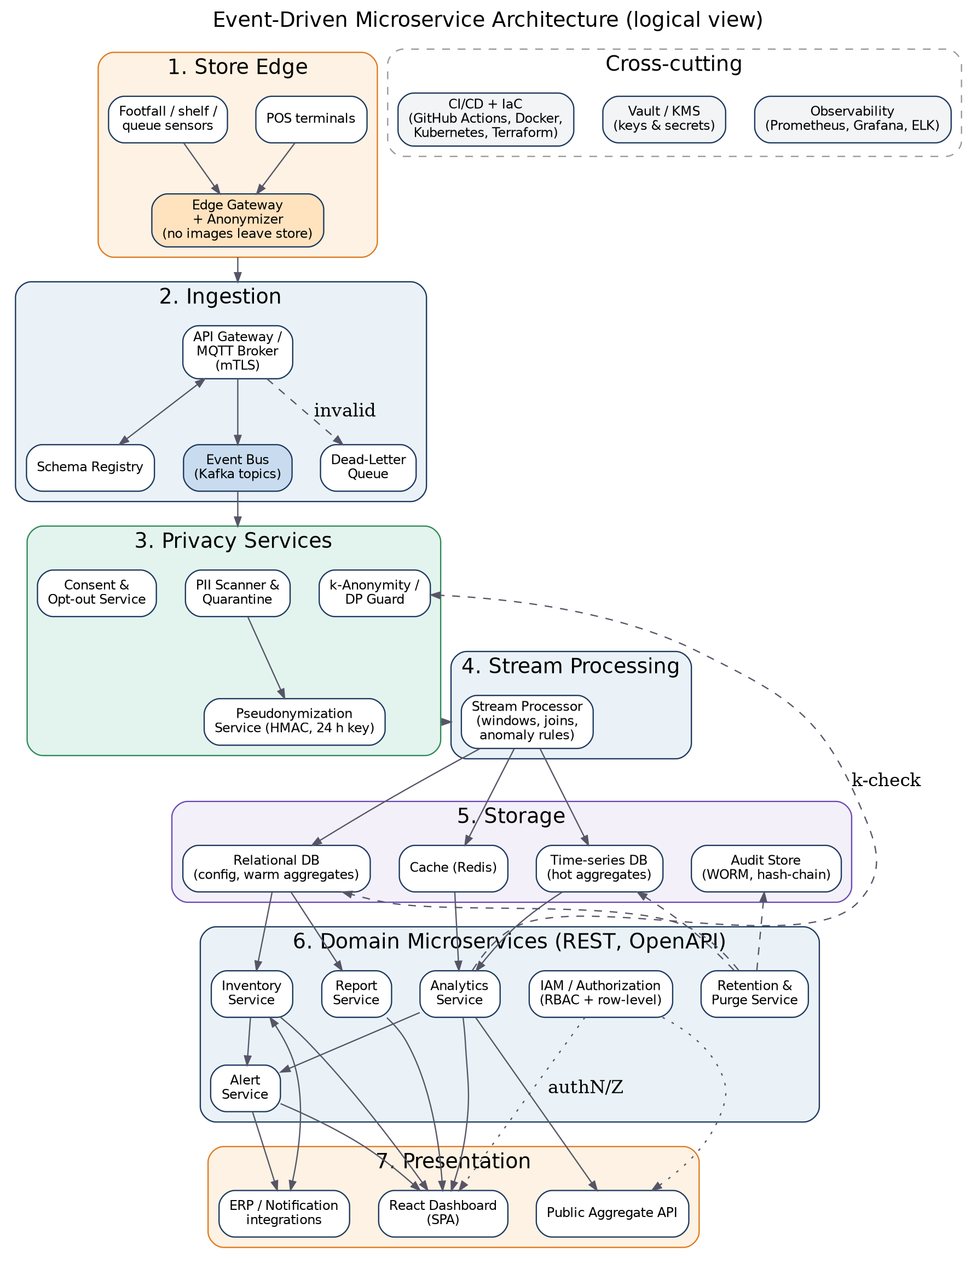
Figure 7: Logical architecture: event-driven microservices with privacy services in the data path

4.2.3 Product Functions (Summary)
- Ingest and validate retail events securely; anonymize at the edge and pseudonymize centrally.
- Compute real-time and historical analytics: footfall, dwell, queues, sales, conversion, stock, forecasts.
- Present role-based dashboards, reports, alerts and a privacy-transparency panel.
- Enforce authentication, authorization, encryption, audit and retention.
- Provide APIs, monitoring, automated testing and CI/CD.

4.2.4 Operating Environment
Cloud-hosted Kubernetes cluster (any provider), containers built with Docker, object/relational/time-series storage, Kafka-compatible event bus, modern evergreen browsers (Chrome, Edge, Firefox, Safari – last two versions) for the web client, and store-side edge gateways running a lightweight Linux container runtime.

4.3 Scope of the System
In scope: event ingestion, validation, anonymization and pseudonymization; real-time and historical operational analytics (footfall, dwell, queues, sales, stock); role-based dashboards, reports, alerts and APIs; access control, encryption, audit trail, retention and deletion; privacy-request handling; monitoring, logging, automated testing and containerised CI/CD; a 50-store pilot with a path to 500.
Out of scope: facial recognition (WN-01), cross-day tracking of individuals (WN-02), sharing individual-level data (WN-03), sensitive inference (WN-04), personalised advertising or pricing (WN-05), sensor hardware manufacture, POS replacement and full ERP functionality.
System boundary. Edge gateways, POS devices and sensors are external suppliers of events; the identity provider, ERP and notification service are external systems. The platform owns everything between event reception and the presentation of aggregates, together with its governance services.

4.4 Functional Requirements
The complete, uniquely identified functional requirements FR-01 to FR-68 are specified in Section 2.2 and form part of this SRS. They are summarised below by module with their purpose and the main verification method.
Verification of the Must requirements is by automated tests: privacy tests with a seeded PII corpus (Modules A–B), replay of recorded event streams (C), role-matrix and penetration tests (F), retention-job and audit hash-chain tests (G), OpenAPI contract tests (H) and pipeline evidence (J). Example acceptance criteria: FR-11 – a zone with 6 visitors returns a suppressed cell and no count; FR-27 – a new footfall event appears on the dashboard within 5 s (p95); FR-39/40 – a Store Manager of store A requesting store B receives 403 and an audit record; FR-50 – no raw events older than 30 days remain after the nightly purge.

4.5 Non-Functional Requirements
The 38 measurable non-functional requirements (NFR-P1 … NFR-G1) in Section 2.4 are part of this SRS. In summary: performance (≤ 5 s latency, 5,000 events/s), security (TLS 1.3, AES-256, MFA, vault), privacy (0 PII, k ≥ 10, DPIA, 24 h purge), reliability and availability (99.9 % / 99.95 %, RPO 15 min, RTO 1 h), scalability (50 → 500 stores), usability (SUS ≥ 75, WCAG 2.1 AA), maintainability (≥ 80 % coverage, config-driven policies), compliance (DPDP/GDPR/ISO 27001), interoperability, observability and sustainability.
Design implications of the NFRs. (1) The 5-second latency and 99.9 % availability require an event bus with replicated partitions and stateless processors. (2) The privacy NFRs require anonymization before persistence and automated privacy tests in the pipeline. (3) Scalability and maintainability require microservices with bounded contexts and declarative infrastructure (IaC). (4) Auditability requires append-only, hash-chained logs that contain no PII.

4.6 Use Case Descriptions
Six critical use cases are described in full; the remaining use cases are summarised in Section 3.3.

UC02: View Real-Time Dashboard
Table 18: Use case description – UC02 View Real-Time Dashboard
Primary actor | Store Manager (also Inventory Manager, Analyst, Executive)
Secondary actors | Identity Provider
Priority / FRs | Must / FR-18 – FR-22, FR-27 – FR-29
Description | The user views live KPIs for the stores in their scope, filters them and drills down.
Preconditions | User authenticated (UC01); events are flowing.
Trigger | User opens the dashboard.
Main flow | 1. System loads KPIs (footfall, conversion, sales, queue, stock) for the user's scope from the hot store/cache.  2. System applies the k-anonymity guard to every cell.  3. System renders KPI tiles, trend and heat-map.  4. Dashboard refreshes at least every 5 s through server push.  5. User applies filters (store, zone, category, time) and drills down.
Alternate / exception flows | 2a. A cell has < k people: it is shown as "insufficient data".  4a. Stream is delayed: a staleness banner shows the last update time (NFR-R3).  5a. No data in range: empty state with explanation.
Postconditions | User sees privacy-safe KPIs; access is logged.
Business rules | Data limited by scope; only aggregates displayed.

UC07: Ingest Retail Events
Table 19: Use case description – UC07 Ingest Retail Events
Primary actor | Retail Event Source (POS, sensor, edge gateway)
Secondary actors | Schema Registry, Event Bus
Priority / FRs | Must / FR-01 – FR-07
Description | Devices send events that are authenticated, validated and published to the event bus.
Preconditions | Device registered with a valid certificate; schema version registered.
Trigger | A device emits an event or a buffered batch.
Main flow | 1. Device sends event over MQTT/HTTPS with mutual TLS.  2. Gateway authenticates the device certificate.  3. System validates the event against the schema and field whitelist.  4. System assigns event ID and ingestion time.  5. Include UC08 (anonymize / pseudonymize).  6. Event is published to the event bus; acknowledgement returned.
Alternate / exception flows | 2a. Certificate invalid or revoked: reject, alert Security.  3a. Schema invalid: route to DLQ, increment error metric.  6a. Bus unavailable: gateway buffers up to 24 h and replays in order.  6b. Duplicate event ID: ignored (idempotent).
Postconditions | Valid, anonymized event is on the bus exactly once in effect.
Business rules | Unknown fields are dropped; no raw images accepted.

UC08: Anonymize and Pseudonymize Data
Table 20: Use case description – UC08 Anonymize and Pseudonymize Data
Primary actor | System (included by UC07)
Secondary actors | Key Management Service (KMS)
Priority / FRs | Must / FR-04, FR-08 – FR-11, FR-17
Description | Removes or transforms identifying information so only privacy-safe data is persisted.
Preconditions | Daily key available in KMS; data-collection register loaded.
Trigger | Event reaches the privacy service (called by UC07).
Main flow | 1. PII scanner inspects the payload for patterns (phone, e-mail, card, name).  2. Fields not in the register are dropped.  3. Device/loyalty identifiers are replaced by HMAC-SHA-256 tokens using the current daily key.  4. Timestamps are generalised to the required precision.  5. Cleaned event is returned for publication.
Alternate / exception flows | 1a. PII found: record quarantined, alert to DPO, event not published.  3a. Key unavailable: events held in buffer; Sev-1 alert raised.
Postconditions | Event contains no direct identifiers; tokens cannot be linked across days.
Business rules | Key rotated every 24 h; old keys destroyed.

UC10: Configure Retention Policies
Table 21: Use case description – UC10 Configure Retention Policies
Primary actor | Privacy / Compliance Officer
Secondary actors | —
Priority / FRs | Must / FR-49, FR-51
Description | The DPO defines how long each data class is kept and what happens at expiry.
Preconditions | DPO authenticated; data classes defined in purpose register.
Trigger | New data class, legal change or periodic review.
Main flow | 1. DPO opens retention settings.  2. DPO selects data class and sets period and action (purge or anonymize).  3. System validates against legal minimum/maximum guidance.  4. DPO confirms; system stores the new policy version.  5. System schedules the purge job (UC17) and writes an audit record.
Alternate / exception flows | 3a. Period exceeds approved maximum: change blocked or needs executive approval.  2a. Legal hold requested: deletion suspended for the selected scope.
Postconditions | Policy active without redeployment (NFR-M4).
Business rules | Raw events ≤ 30 days; policy changes versioned and audited.

UC12: Handle Privacy Requests
Table 22: Use case description – UC12 Handle Privacy Requests
Primary actor | Customer (Data Subject)
Secondary actors | Privacy Officer, Notification Service
Priority / FRs | Must / FR-14 – FR-16
Description | A customer opts out of analytics or requests access or erasure of loyalty-linked data.
Preconditions | Privacy notice displayed; request channel available (QR/web).
Trigger | Customer submits a request.
Main flow | 1. Customer submits request with a verification token.  2. System verifies the requester (OTP).  3. System creates a ticket and starts the 30-day SLA clock.  4. DPO reviews the request.  5. System applies the action: suppression list (opt-out), data report (access) or erasure.  6. System propagates the change to all services.  7. Customer is notified and the ticket is closed with an audit record.
Alternate / exception flows | 2a. Verification fails: more proof requested or request refused with reason.  4a. Legal hold or exemption applies: refusal explained and recorded.  7a. SLA at risk: automatic escalation.
Postconditions | Customer's choice honoured within 24 h (opt-out) or 30 days (access/erasure).
Business rules | Anonymous aggregates are not personal data and are not re-computed.

UC17: Purge Expired Data
Table 23: Use case description – UC17 Purge Expired Data
Primary actor | Scheduler (time trigger)
Secondary actors | Privacy Officer (oversight)
Priority / FRs | Must / FR-50, FR-52
Description | Automatically deletes or anonymizes data whose retention period has expired.
Preconditions | Active retention policies; no legal hold on the target data.
Trigger | Nightly schedule.
Main flow | 1. Retention Service reads active policies.  2. It selects expired records per data class.  3. It excludes data under legal hold.  4. It purges or irreversibly anonymizes the records.  5. It writes a deletion record (counts, class, time) to the audit store.  6. It reports completion to monitoring.
Alternate / exception flows | 4a. Purge failure: retry; after 3 failures raise privacy alert to DPO and Security.
Postconditions | No expired data remains; evidence recorded.
Business rules | Purge completes within 24 h of expiry (NFR-PR4).

4.7 Data Requirements

4.7.1 Logical Data Model
The logical model separates operational/analytical data (events, transactions, inventory, aggregates), configuration (stores, devices, alert rules), identity and access (users, roles, permissions), and governance data (audit log, retention policy, consent records, privacy requests). Customer-linked identifiers appear only as tokens; consent tokens are never joined to events except through the pseudonymization service.
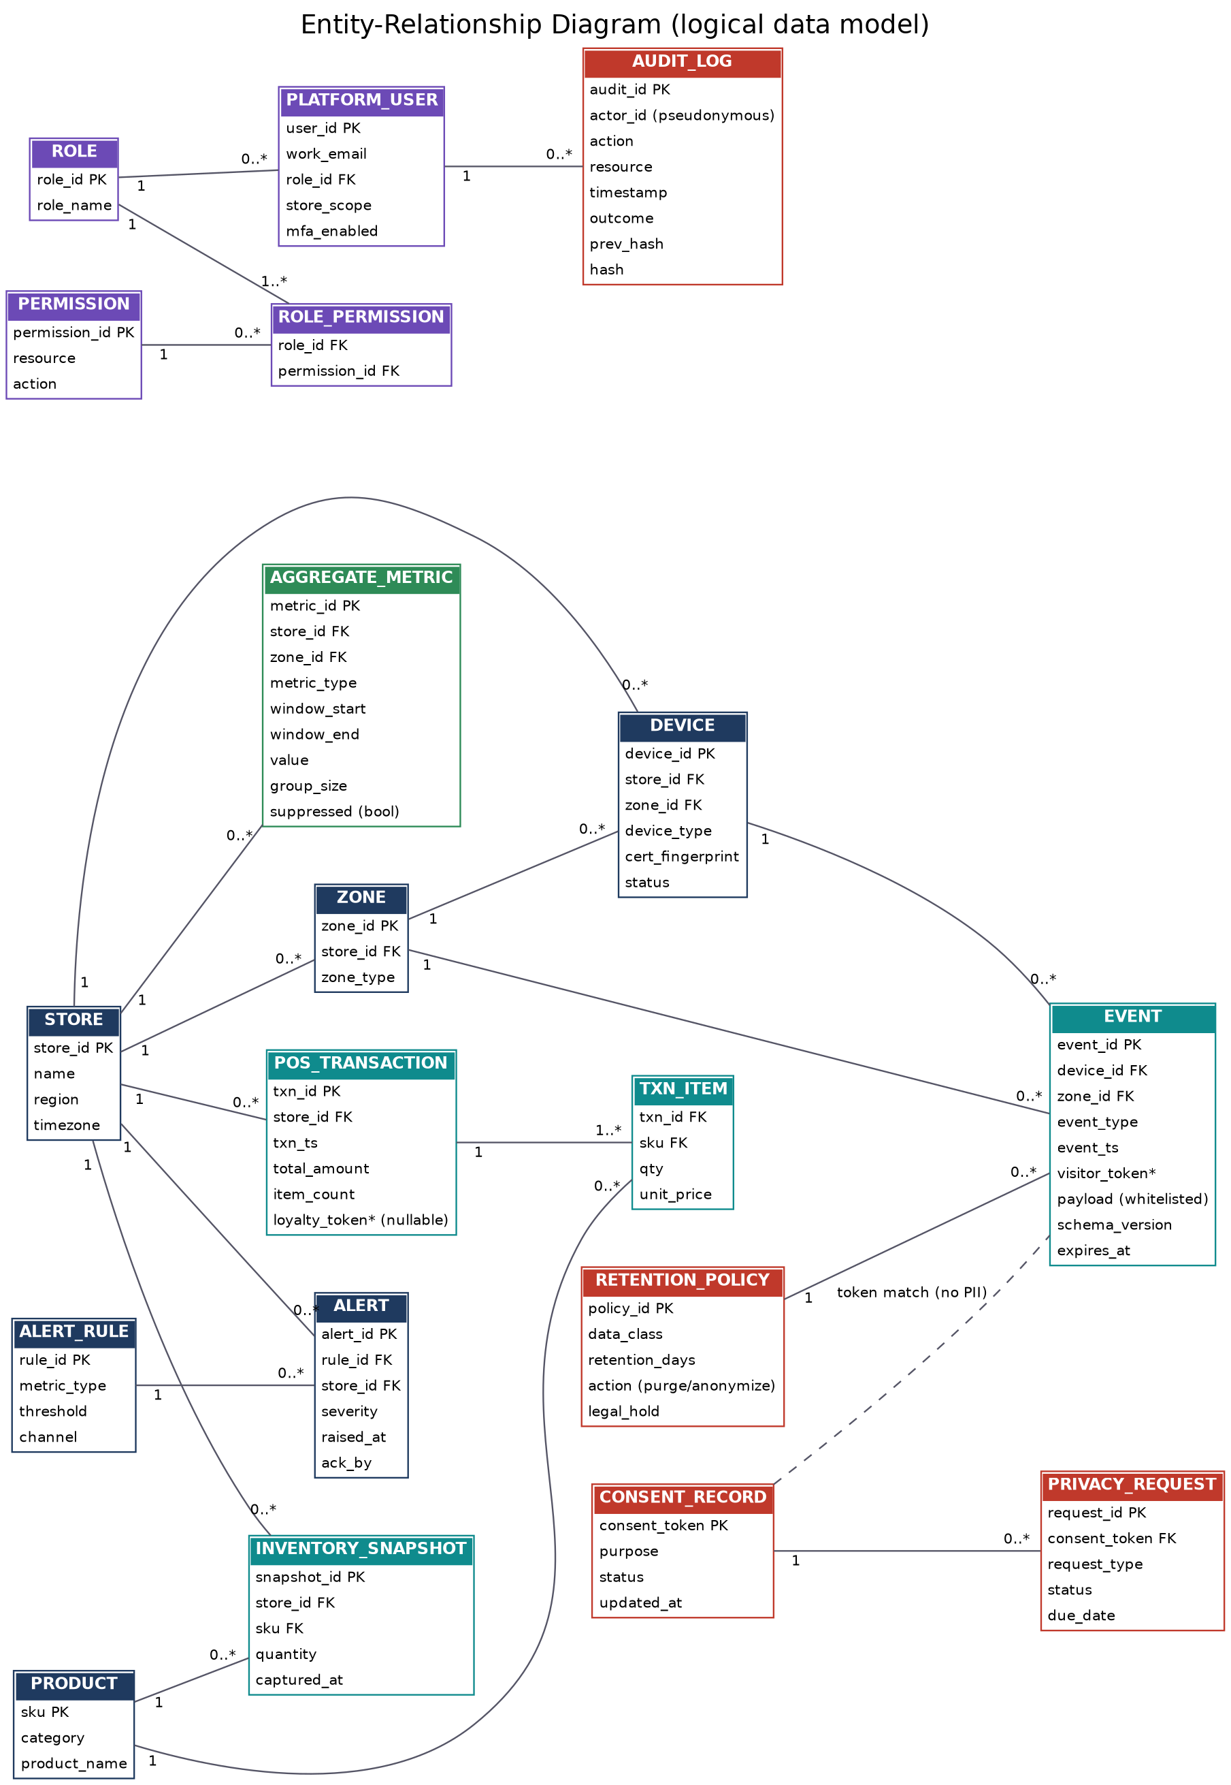
Figure 8: Entity-relationship diagram of the logical data model

4.7.2 Data Dictionary (key entities)
Table 24: Data dictionary and classification
Entity | Attribute | Type | Class | Notes
EVENT | event_id | UUID | Internal | Unique; used for de-duplication
EVENT | event_type | Enum | Internal | footfall, queue, shelf, scan, heartbeat
EVENT | event_ts | Timestamp (UTC) | Internal | Generalised to seconds
EVENT | visitor_token | CHAR(64) | Pseudonymous | HMAC with daily key; unlinkable across days
EVENT | payload | JSON | Internal | Only whitelisted fields
EVENT | expires_at | Timestamp | Internal | Set from retention policy (raw 30 days)
POS_TRANSACTION | txn_id, store_id, txn_ts | UUID, INT, TS | Internal | No card data
POS_TRANSACTION | total_amount, item_count | Decimal, INT | Internal | Business metric
POS_TRANSACTION | loyalty_token | CHAR(64) | Pseudonymous | Nullable; only with consent
INVENTORY_SNAPSHOT | sku, quantity, captured_at | STR, INT, TS | Internal | Per store
AGGREGATE_METRIC | metric_type, window_start/end, value | Enum, TS, Decimal | Aggregated | Safe to display
AGGREGATE_METRIC | group_size, suppressed | INT, BOOL | Aggregated | Supports k-anonymity check
PLATFORM_USER | user_id, work_email, role_id | UUID, STR, FK | Personal (employee) | Only employees; MFA flag stored
ROLE / PERMISSION | role_name, resource, action | STR | Internal | RBAC definitions
AUDIT_LOG | actor_id, action, resource, timestamp, outcome | Pseudonymous ID, STR, TS | Internal | No customer PII; hash-chained (prev_hash, hash)
RETENTION_POLICY | data_class, retention_days, action, legal_hold | STR, INT, ENUM, BOOL | Internal | Versioned; editable by DPO
CONSENT_RECORD | consent_token, purpose, status | CHAR(64), STR, ENUM | Pseudonymous | Opt-out / consent state
PRIVACY_REQUEST | request_id, type, status, due_date | UUID, ENUM, ENUM, DATE | Internal | 30-day SLA tracking

4.7.3 Data Classification
Data is handled in six classes: direct PII (never collected; quarantined if detected), quasi-identifiers (generalised or hashed at ingestion), pseudonymous tokens (keyed hash, daily key rotation, kept 30 days), aggregated metrics (k ≥ 10, kept 13 months), employee data (encrypted, RBAC, MFA, separate identity store) and governance data (audit logs and policies in write-once storage, no PII). The analytics store may hold only pseudonymous and aggregated data. Volume is estimated at about 54 million events (≈ 15 GB) per day for 50 stores, i.e. ≈ 450 GB for the 30-day raw window.

4.7.4 Retention and Deletion Requirements
Table 25: Default retention schedule
Data class | Retention | Action at expiry | Rationale
Edge buffer (offline only) | ≤ 24 h | Delete after replay | Only needed during outage
Pseudonymized raw events | 30 days | Purge | Debugging and recomputation window
Hourly / daily aggregates | 13 months | Archive then purge | Year-over-year comparison
Audit logs (online) | 12 months | Move to cold archive | Investigations and audits
Audit logs (archive) | 3 years | Purge | Regulatory evidence
Consent and request records | 3 years after closure | Purge | Prove that rights were honoured
Backups | 35 days | Overwrite | Aligned with deletion promises
All periods are defaults that the Compliance Officer can change (FR-49) and are subject to confirmation by legal counsel (see AMB-4 in Section 6).
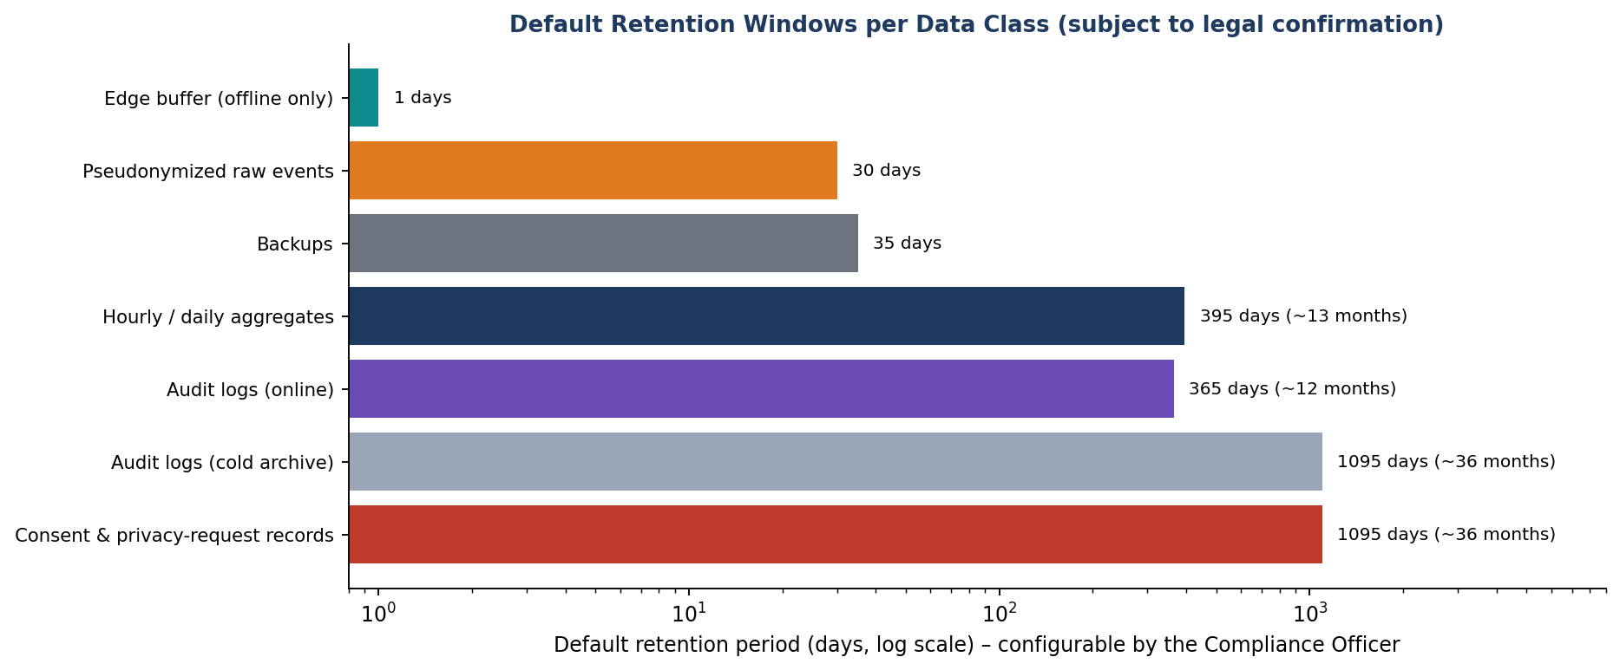
Figure 9: Default retention windows per data class

4.7.5 Data Integrity, Quality and Flow Requirements
- Every event carries an ID and schema version; duplicates are ignored and invalid events are never silently dropped (DLQ).
- Late events up to 5 minutes are included in windows; later events are logged and counted separately.
- Sensor gaps are flagged in the data so that dashboards show "no data" rather than zero.
- Backups, caches and search indexes must obey the same retention and erasure rules as primary stores.
The following flowchart shows the end-to-end path of an event through the privacy and processing pipeline, including every rejection and suppression point.
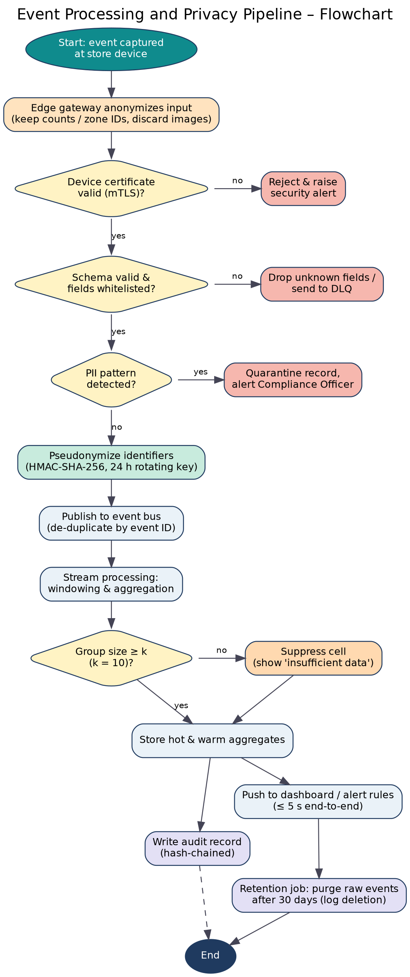
Figure 10: Event processing and privacy pipeline flowchart
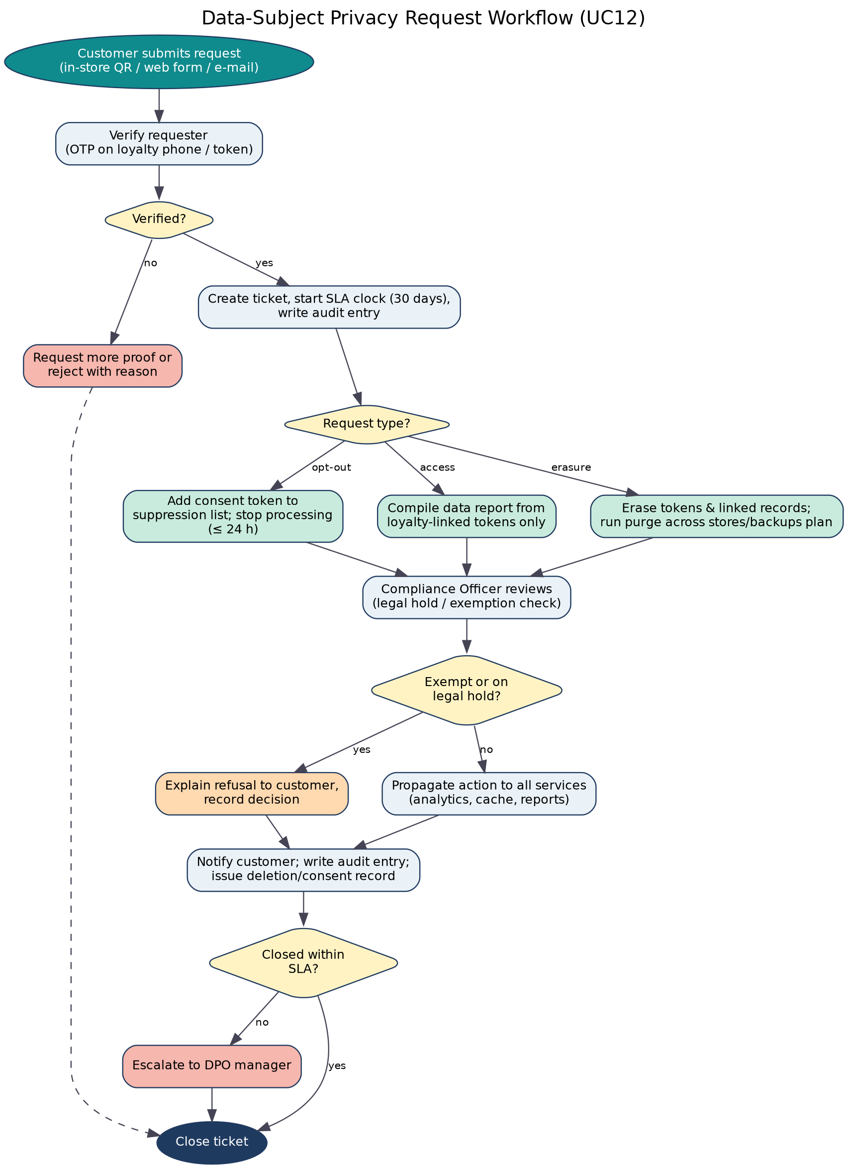
Figure 11: Data-subject privacy request workflow (UC12)

4.8 External Interface Requirements

4.8.1 User Interfaces
The web client is a single-page application (React) that is responsive, accessible (WCAG 2.1 AA) and role-aware. It shows only the menu items and data allowed for the role. The wireframe below illustrates the Store Manager view: KPI tiles, trend, heat-map with suppressed cells, shelf availability, alerts and a privacy-transparency panel.
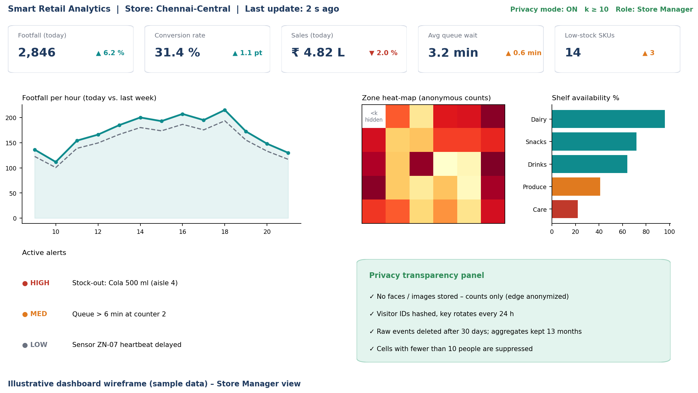
Figure 12: Illustrative dashboard wireframe (sample data) – Store Manager view
UI standards: consistent navigation, plain-language privacy text (grade ≤ 8), keyboard operable, colour-blind-safe charts, error messages that never reveal personal or system details, session-timeout warning.

4.8.2 Hardware Interfaces
- Footfall sensors / thermal or depth counters that output counts only (no image export).
- Shelf weight/RFID/vision-count sensors, queue sensors and POS terminals connected via the store LAN to the edge gateway.
- Edge gateway: x86/ARM device with ≥ 4 GB RAM, 32 GB storage for 24-hour buffer, TPM or secure element for the device key.

4.8.3 Software Interfaces
- Identity Provider: OpenID Connect / OAuth 2.0 for sign-in and MFA. Event bus: Kafka protocol with CloudEvents and a schema registry.
- ERP / Inventory: REST and webhooks (SKU master data in, replenishment out). Notification service: SMTP, SMS gateway and push APIs.
- Key management: cloud KMS API for daily HMAC keys. Monitoring: Prometheus scrape and OpenTelemetry; CI/CD: Git, GitHub Actions, container registry, Helm, Terraform.

4.8.4 Communication Interfaces
- All external traffic over HTTPS (TLS 1.3); device traffic over MQTT over TLS or HTTPS with mutual authentication.
- Real-time dashboard updates through WebSocket / Server-Sent Events; REST (JSON) for queries.
- Internal service-to-service traffic encrypted with mTLS inside the cluster; network policies deny by default.

4.8.5 API Interface (API-first, OpenAPI 3.x, versioned /v1)
Table 26: Principal API endpoints
Endpoint | Purpose | Authorization | Notes
POST /v1/ingest/events | Device event submission | Device cert (mTLS) | Schema-validated; 202 Accepted
GET /v1/stores/{id}/kpis/realtime | Real-time KPIs | Dashboard roles | Aggregates only
GET /v1/stores/{id}/footfall | Footfall by window | Store Mgr, Analyst | Params: window, from, to
GET /v1/stores/{id}/zones/heatmap | Zone heat-map | Store Mgr, Analyst | k-suppression applied
GET /v1/stores/{id}/inventory | Stock and availability | Inventory Mgr | —
GET /v1/forecast/demand | Demand forecast | Inventory Mgr, Analyst | Category level
GET/POST /v1/alert-rules | Manage alert rules | Role-scoped | Audited changes
GET /v1/alerts | Active alerts | Role-scoped | Pagination
POST /v1/reports · GET /v1/reports/{id} | Generate / fetch report | Role-scoped | PDF/CSV/XLSX
POST /v1/privacy/requests · GET …/{id} | Customer privacy requests | Customer token / DPO | SLA tracking
GET/PUT /v1/retention/policies | Retention policy | DPO (PUT), others read | Versioned
GET /v1/audit/logs | Audit search | DPO, Auditor, Admin | Chain verification flag
GET/POST /v1/users · /roles | Access management | Admin (+ DPO approval) | —
GET /v1/health · /metrics | Health and Prometheus metrics | Internal | No PII
Error handling follows RFC 7807 problem-details; rate limiting returns 429; breaking changes require a new major version path.

4.9 System Features
Table 27: System features
ID | Feature | Description | Stimulus → response | Priority | FRs
SF-01 | Secure event ingestion | Authenticated, schema-validated, de-duplicated event intake with edge buffering | Device event → accepted, validated event on bus; invalid → DLQ | Must | FR-01 – FR-07
SF-02 | Privacy engine | Edge anonymization, PII scanning, pseudonymization, k-anonymity, optional DP noise, purpose register | Raw event → privacy-safe event; small group → suppressed cell | Must | FR-08 – FR-17
SF-03 | Real-time analytics | Windowed streaming aggregations for footfall, dwell, queues, sales, stock, forecast, anomalies | Event stream → updated aggregates within seconds | Must | FR-18 – FR-26
SF-04 | Dashboards and reports | Role-based live dashboards, drill-down, exports, privacy panel | User request → privacy-safe visualisation or file | Must | FR-27 – FR-33
SF-05 | Alerting | Threshold, anomaly and privacy/security alerts with escalation | Threshold crossed → notification and acknowledgement flow | Must | FR-34 – FR-37
SF-06 | Identity and access control | SSO, MFA, RBAC, row-level scope, encryption, API security | Login / API call → authorised or denied with audit record | Must | FR-38 – FR-45
SF-07 | Audit and retention | Tamper-evident audit trail, retention schedules, purge, legal hold, compliance report | Schedule or request → purge/evidence generated | Must | FR-46 – FR-53
SF-08 | API and integration | Versioned REST API, ERP/POS adapters, sandbox | Client call → aggregated response | Must | FR-54 – FR-57
SF-09 | Monitoring and operations | Metrics, logs, alerts on lag, auto-scaling, backup/restore | Anomaly or load → alert or scale-out | Must | FR-58 – FR-62
SF-10 | Automated testing and CI/CD | Pipeline with unit, integration, privacy, security and load tests; blue-green release; rollback | Commit → tested artifact → gated deployment | Must | FR-63 – FR-68
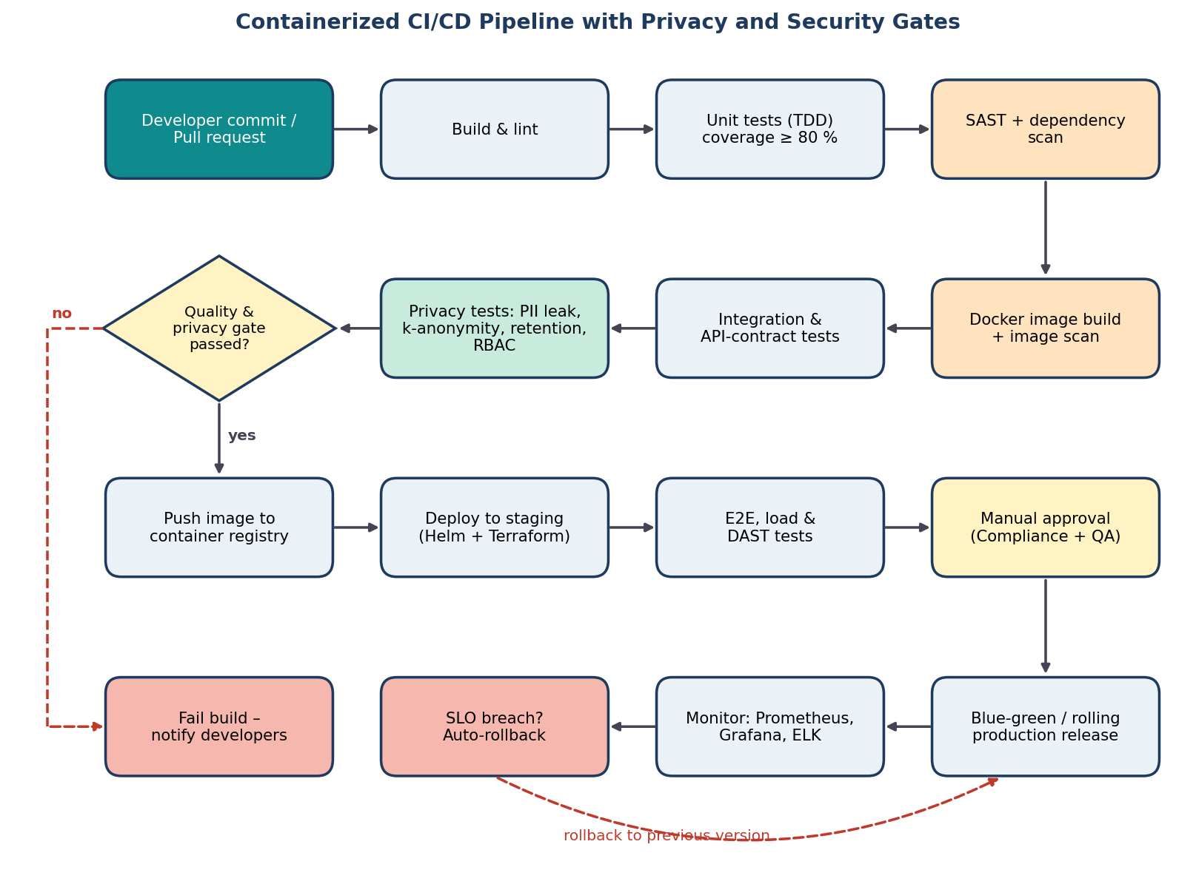
Figure 13: Containerized CI/CD pipeline with privacy and security gates (SF-10)

5. Assumptions and Constraints

5.1 Assumptions
Assumptions are conditions believed to be true while writing this specification. If an assumption proves false, the affected requirements must be revisited; the last column states what would be affected.
Table 28: Assumptions
ID | Assumption | Affected requirements if false | Risk
A-01 | Every store has stable power, LAN and internet (≥ 5 Mbps upstream); outages last at most 24 hours. | FR-06, NFR-A2 | Medium
A-02 | Footfall and queue sensors can output counts/anonymous attributes without exporting images (vendor-supported). | FR-04, NFR-PR1 | High
A-03 | Existing POS systems can emit transaction events (API or webhook) without card data. | FR-01, FR-55 | Medium
A-04 | The organisation has an identity provider supporting OpenID Connect and MFA. | FR-38 | Low
A-05 | A Privacy/Compliance Officer is appointed with authority to approve policies and DPIA. | FR-49, NFR-PR3 | Medium
A-06 | Cloud infrastructure with Kubernetes and a Kafka-compatible service is available (managed or self-hosted). | NFR-SC1, FR-61 | Low
A-07 | Customers are informed by store signage and a privacy notice; a lawful basis has been confirmed by legal advice. | FR-14, NFR-C1 | Medium
A-08 | Pilot size is 50 stores in one region with ≤ 5,000 events/s at peak. | NFR-P4, NFR-SC1 | Low
A-09 | Users have modern browsers and receive ≤ 30 minutes of training. | NFR-U1 | Low
A-10 | SKU master data from the ERP is available and of acceptable quality. | FR-22, FR-55 | Medium
A-11 | Loyalty-linked analytics is optional and only for customers who have consented. | FR-14 – FR-16 | Medium
A-12 | The first release UI is in English; Tamil and Hindi follow. | NFR-U3 | Low
A-13 | A team of about five engineers works in Scrum with two-week sprints for 16 weeks. | Schedule (Section 5.3) | Medium
A-14 | Open-source licences (Apache-2.0, MIT, BSD) are acceptable to the organisation. | Technology choices | Low
A-15 | Legal counsel will confirm retention durations and k-threshold before go-live. | FR-49, NFR-PR2, AMB-4 | Medium

5.2 Constraints
Table 29: Constraints by category
ID | Constraint | Impact on design | Mitigation
Technical constraints
C-T1 | Edge gateways have limited CPU/RAM for anonymization. | Lightweight models; counting only, no image retention | Benchmark early; offload to micro-batch at edge cluster
C-T2 | Store connectivity is intermittent. | Need local buffering and ordered replay | 24-hour edge buffer (FR-06); idempotent processing
C-T3 | Heterogeneous POS and sensor protocols. | Adapters and canonical event schema needed | Schema registry; adapter pattern; CloudEvents
C-T4 | Stack must use containers, CI/CD and open standards (course and organisational policy). | Docker, Kubernetes, OpenAPI, OIDC mandatory | Reference architecture; ADRs
C-T5 | k-anonymity windows conflict with 5-second latency (INC-4). | Minimum aggregation window of 1 minute for small cells | Show suppressed cells; larger windows for small zones
Operational constraints
C-O1 | Stores operate long hours; downtime hurts operations. | Zero-downtime deployment and graceful degradation | Blue-green releases; cached dashboards (NFR-R3)
C-O2 | Very limited IT staff in stores. | Remote management and self-healing required | Central monitoring, auto-restart, remote updates
C-O3 | Privacy-affecting changes need DPO approval. | Release gate and approval step | Manual approval stage in CI/CD
C-O4 | Staff turnover is high. | UI must be learnable quickly | Role-based simple views; in-app help
Economic constraints
C-E1 | Limited pilot/capstone budget. | Prefer open-source and managed services on pay-as-you-go | Cost review each sprint; avoid licence-heavy tools
C-E2 | Cloud cost grows with data volume. | Storage and compute must be controlled | Retention limits, downsampling, auto-scale down
C-E3 | Sensor and hardware procurement is a separate budget. | Assume existing devices where possible | Define minimum device capability list
Legal and ethical constraints
C-L1 | DPDP Act 2023 and GDPR obligations: notice, purpose limitation, consent where required, erasure, breach reporting. | Privacy functions are mandatory, not optional | Privacy requirements are Must; DPIA before release
C-L2 | No biometric identification or sensitive inference. | Face recognition and emotion detection excluded | WN-01 and WN-04
C-L3 | Data-processing agreements are needed with sensor, cloud and notification vendors. | Procurement dependency | Open item MIS-7; legal templates
C-L4 | Possible data-localisation / cross-border transfer limits. | Hosting region must be chosen carefully | Deploy in an India region; document transfers
Time constraints
C-TM1 | Fixed 16-week schedule. | Strict prioritization (MoSCoW) | Deliver Must items first; Could items deferred
C-TM2 | DPIA and legal review need lead time. | Must start in weeks 4–5 | Parallel privacy track in the schedule
C-TM3 | Sprint cadence of two weeks. | Requirements must be sliceable into sprint backlog items | Epics per module A–J; user stories per FR
C-TM4 | Pilot window limited to the final weeks. | Little room for late rework | Early prototype; continuous testing

5.3 Indicative Schedule
The following Gantt chart shows how the time constraint shapes the plan: requirements and architecture come first, the privacy/DPIA track runs in parallel with development, and CI/CD is introduced early so that testing is continuous.
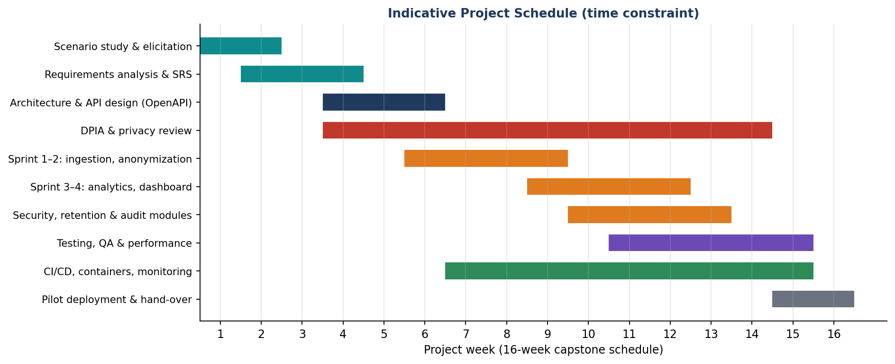
Figure 14: Indicative 16-week project schedule
Summary of Step 5. Fifteen assumptions and twenty constraints (technical 5, operational 4, economic 3, legal and ethical 4, time 4) were recorded, each with its impact and a mitigation.

6. Validation of Requirement Completeness and Consistency

6.1 Validation Approach
The specification was validated with four complementary techniques: (1) a checklist review against the quality characteristics of IEEE 29148, (2) coverage analysis from stakeholders and objectives to requirements, (3) a structured defect review for ambiguity, redundancy, inconsistency and omissions, and (4) traceability from objectives through requirements and use cases to tests. Risks to the requirements themselves were assessed in a risk register.
Each requirement was checked against the IEEE 29148 characteristics – necessary (traces to a stakeholder and objective), unambiguous, complete, consistent, feasible, verifiable, traceable and non-redundant. All 68 functional requirements have at least one stakeholder and one objective; the exceptions found are listed in Section 6.3.

6.2 Stakeholder Requirement Coverage
Verification that all stakeholder requirements are addressed: every stakeholder owns at least six requirements, and the Compliance Officer – the most requirement-intensive role because of the privacy objective – owns 23.
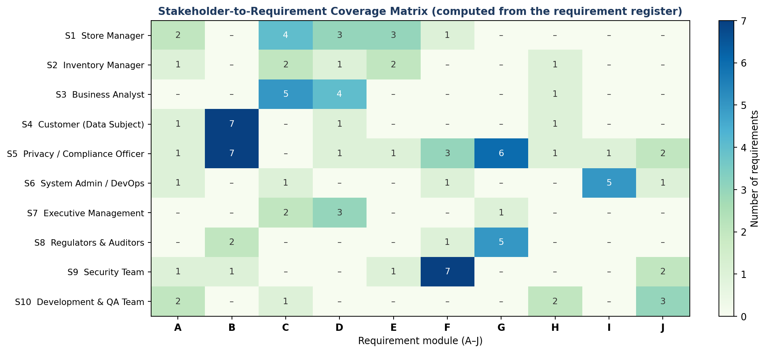
Figure 15: Stakeholder-to-module coverage matrix computed from the requirement register

Objective coverage
Table 30: Coverage of the seven objectives
# | Objective | FR count | Non-functional support | Status
O1 | Real-time retail operational analytics | 22 | NFR-P1 – P5 | Covered
O2 | Minimize unnecessary customer information | 9 | NFR-PR1, PR2 | Covered
O3 | Secure data processing & access control | 15 | NFR-S1 – S5 | Covered
O4 | Audit trails & retention policies | 11 | NFR-C2, PR4 | Covered
O5 | Scalable event-driven services | 15 | NFR-SC1 – SC3, A1 – A3, R1 – R4 | Covered
O6 | Automated testing & CI/CD | 7 | NFR-M2, M3 | Covered
O7 | Ethical & privacy requirements | 16 | NFR-PR3, PR5, C1 | Covered

6.3 Ambiguity, Redundancy, Inconsistency and Missing-Requirement Checks
The problem statement contains terms that cannot be tested ("real-time", "scalable", "secure", "minimizing"); each was converted into a measurable requirement. Conflicts were mainly between business analytics wishes and the privacy objective and were resolved with explicit rules. Twenty findings were recorded; 18 are resolved and 2 remain open because they need external confirmation.
Table 31: Validation findings and corrections
ID | Finding in draft | Correction in this SRS | Status
AMB-1 | "Real-time analytics" has no measurable meaning. | Defined as ≤ 5 s p95 event-to-dashboard latency (NFR-P1, FR-27). | Resolved
AMB-2 | "Minimize unnecessary customer information" is subjective. | Replaced by whitelist register and prohibited-data list (FR-08, FR-09). | Resolved
AMB-3 | "Scalable" is not quantified. | Quantified: 5,000 events/s per region, 50 → 500 stores (NFR-P4, NFR-SC1). | Resolved
AMB-4 | "Retention policies" given without durations. | Default durations proposed per data class and made configurable (FR-49). | Open – legal confirmation of durations pending
AMB-5 | "Secure APIs" is not testable. | Specified OAuth 2.0 scopes, TLS 1.3, rate limiting (FR-43, NFR-S1). | Resolved
AMB-6 | "Small groups" not defined for privacy protection. | Minimum group size k = 10 configurable (FR-11, NFR-PR2). | Resolved
RED-1 | Purge logging stated both in audit and retention requirements. | Single rule: purge runs are recorded through the audit trail (FR-46, FR-50). | Resolved
RED-2 | Encryption stated separately for API, storage and backups. | Consolidated into one requirement (FR-44). | Resolved
RED-3 | Access reviews appeared in dashboard and compliance requirements. | Kept only in FR-45; compliance report references it. | Resolved
INC-1 | Analysts want 90-day raw data; minimization limits raw data to 30 days. | Raw pseudonymized events 30 days; aggregates 13 months for trends. | Resolved
INC-2 | Marketing wants multi-day visitor journeys; 24-hour key rotation prevents linking. | Journeys allowed within one day; multi-day insight from aggregates only. | Resolved
INC-3 | Audit logs must be immutable but erasure rights require deletion. | Audit logs hold no PII (pseudonymous IDs); erasure applies to loyalty-linked data. | Resolved
INC-4 | 5-second latency vs. k-threshold checks on small windows. | k-check applied on streaming window ≥ 1 minute; fine-grained cells suppressed. | Resolved
MIS-1 | No handling of sensor outage / data gaps. | Added anomaly detection and data-quality alerts (FR-24, FR-60). | Resolved
MIS-2 | No disaster-recovery objectives. | Added FR-62 and NFR-R4 (RPO/RTO). | Resolved
MIS-3 | No data-subject rights workflow. | Added FR-15 and FR-16. | Resolved
MIS-4 | No accessibility requirement. | Added NFR-U2 (WCAG 2.1 AA). | Resolved
MIS-5 | No legal-hold mechanism. | Added FR-51. | Resolved
MIS-6 | No localization requirement. | Added NFR-U3. | Resolved
MIS-7 | No data-processing agreements with sensor/cloud vendors. | Recorded as constraint C-L3; procurement action required. | Open – needs vendor contracts

6.4 Requirements Traceability Matrix
Traceability links every objective to requirements, use cases, architecture elements and verification, so that gaps and impact of change are visible.
Table 32: Traceability matrix (objective → requirements → use cases → verification)
Obj. | Functional requirements | Non-functional | Use cases | Architecture element | Verification
O1 | FR-18 – 33; FR-25 | NFR-P1 – P5, R3 | UC02 – UC06, UC16 | Stream processor, analytics service, dashboard | Replay tests; latency load test
O2 | FR-04, 08 – 12, 17, 56 | NFR-PR1, PR2 | UC07, UC08 | Edge anonymizer, PII scanner, pseudonymization, k-guard | Seeded-PII tests; k-threshold tests
O3 | FR-02, 38 – 45, 66 | NFR-S1 – S5 | UC01, UC09 | IAM service, API gateway, KMS | Pen test; RBAC tests; scans
O4 | FR-13, 46 – 53 | NFR-C2, PR4 | UC10, UC11, UC15, UC17 | Audit store, retention service | Purge-job and hash-chain tests
O5 | FR-03, 05, 06, 25, 61, 62 | NFR-SC1 – SC3, A1 – A3, R1 – R4 | UC07, UC13 | Event bus, stateless services, Kubernetes HPA | Chaos and failover drills; scale test
O6 | FR-63 – 68 | NFR-M2, M3, O1 | UC18 | CI/CD pipeline, registry, IaC | Pipeline run evidence
O7 | FR-13 – 16, 32, 36, 65 | NFR-PR3, PR5, C1 | UC10, UC12, UC15 | Consent service, privacy console, DPIA | DPIA sign-off; DSR drill

6.5 Risk Assessment of the Requirement Set
Table 33: Requirement risk register
ID | Risk | Likelihood (1–5) | Impact (1–5) | Score | Mitigation
R1 | Ambiguous terms ("real-time", "scalable") lead to different interpretations | 4 | 3 | 12 | Measurable NFRs; glossary; acceptance criteria
R2 | Re-identification through small groups or combined datasets | 2 | 5 | 10 | k ≥ 10, suppression, optional DP; privacy tests
R3 | Sensor or vendor failure causes data gaps | 4 | 3 | 12 | Data-quality flags; anomaly alerts; redundancy
R4 | Regulatory changes (DPDP rules, sector guidance) | 3 | 4 | 12 | Configurable policies; periodic legal review
R5 | Scope creep from analytics requests | 4 | 3 | 12 | MoSCoW; "Won't have" list; change control
R6 | Stakeholder conflict between analytics and privacy | 3 | 4 | 12 | Documented conflict-resolution rules; DPO authority
R7 | Performance shortfall at peak load | 3 | 4 | 12 | Early load tests; auto-scaling; backpressure
R8 | Insider misuse of privileged access | 2 | 5 | 10 | MFA, least privilege, break-glass, audit review
R9 | Retention or purge job failure | 2 | 4 | 8 | Monitoring and alert; deletion records; tests
R10 | Cost or schedule overrun | 3 | 3 | 9 | Iteration plan; open-source stack; cost review

6.6 Recommendations to Improve Quality and Completeness
- Confirm with real stakeholders. Hold a workshop with a store manager, an inventory manager, the DPO and an auditor to confirm priorities and the k threshold (interviews/focus groups, Unit 2).
- Complete the DPIA and legal review before design freeze; confirm retention periods (AMB-4) and vendor agreements (MIS-7).
- Threat-model the data path (STRIDE / privacy threat modelling such as LINDDUN) to find re-identification and insider risks missed by requirements review.
- Convert requirements to executable acceptance tests (BDD with Gherkin) and keep them in the repository so that requirements and tests evolve together.
- Apply design by contract / formal specification to the two most critical components – the k-anonymity guard and the retention purge – with pre- and post-conditions and property-based tests (syllabus: formal verification and design by contract).
- Maintain a living backlog and traceability in Jira/Confluence, with baselining and change control; every change to a Must requirement requires DPO and QA review.
- Prototype early. Build a clickable dashboard and a simulated event stream to validate usability and latency assumptions before full development.
- Define a measurement plan for NFR targets (who measures, with which tool, when) and add the figures to the Grafana dashboards and release checklist.
- Review sustainability. Track CI pipeline energy and cloud utilisation (NFR-G1) as part of the sustainability audit in the capstone.

6.7 Validation Conclusion
All 10 stakeholder groups, all 7 objectives and all 18 use cases are covered by requirements; 18 of 20 review findings (90 %) are resolved, and every Must requirement has a measurable acceptance criterion.
The specification is therefore judged complete, consistent and sufficiently unambiguous for design to begin. Two open items depend on external parties and are tracked in the risk register rather than being left implicit.

Rubrics for Calculation
Criteria | Excellent (4 Marks) | Good (3 Marks) | Satisfactory (2 Marks) | Needs Improvement (1 Mark)
Scenario Understanding and Problem Analysis (30%) | Demonstrates thorough understanding of the scenario, stakeholders, objectives, and business context with clear analysis. | Demonstrates good understanding with minor omissions. | Basic understanding with limited analysis. | Poor understanding; major aspects missing or incorrect.
Functional and Non-Functional Requirement Identification (25%) | Clearly identifies comprehensive, accurate, and well-classified functional and non-functional requirements. | Identifies most requirements with minor classification errors. | Identifies only basic requirements; several omissions. | Requirements are incomplete, inaccurate, or poorly classified.
Actor Identification and Use Case Modelling (20%) | Correctly identifies all relevant actors and use cases; use case diagram is complete, accurate, and follows UML standards. | Most actors and use cases identified; diagram has minor errors. | Limited actors/use cases identified; diagram partially correct. | Actors/use cases missing or incorrect; diagram absent or inaccurate.
Software Requirement Specification (SRS) Documentation (15%) | SRS is well-structured, complete, professionally organized, and includes all required sections. | SRS is organized with minor missing sections or formatting issues. | SRS includes only essential sections with limited detail. | SRS is incomplete, poorly organized, or lacks essential components.
Assumptions, Constraints, and Requirement Validation (10%) | Clearly identifies realistic assumptions and constraints; validates requirements for completeness, consistency, and ambiguity with appropriate justification. | Identifies most assumptions and constraints; validation is adequate. | Limited assumptions/constraints; validation is superficial. | Assumptions, constraints, and validation are missing or incorrect.

Criteria | Mark
Scenario Understanding and Problem Analysis (30%) | /5
Functional and Non-Functional Requirement Identification (25%) | /5
Actor Identification and Use Case Modelling (20%) | /5
Software Requirement Specification (SRS) Documentation (15%) | /5
Assumptions, Constraints, and Requirement Validation (10%) | /5
TOTAL | /25

